StudyOS Phase 0 - Software Design Specification
Implementation-ready C4, ERD, package architecture, API/event/WS contracts, sequence flows and backlog
StudyOS Engineering Blueprint
10 September 2026
Table of Contents

1 Executive Implementation Baseline
This document is the Phase 0 design freeze for StudyOS. It is intended to be used immediately before implementation starts. The product thesis inherited from the master blueprint remains: StudyOS converts heterogeneous learning sources into an evidence-based learning loop, not merely a source-chat notebook.
The implementation baseline is:
- Next.js + TypeScript web application;
- Spring Boot modular monolith as the business/authorization source of truth;
- FastAPI as a separately deployable AI/retrieval/tutor boundary;
- Python workers for asynchronous ingestion and artifact work;
- PostgreSQL + pgvector + PostgreSQL full-text search;
- Redis for ephemeral coordination/WebSocket replay/rate limits;
- RabbitMQ with transactional outbox and at-least-once delivery;
- S3/MinIO object storage;
- contract-first REST, WebSocket and event interfaces;
- evidence-based mastery owned by Core Learning, never directly by the LLM.

1.1 How to Use This Pack
- Treat this master document as the human-readable architecture/design baseline.
- Treat YAML/JSON/SQL/CSV files in the pack as machine-readable source-of-truth contracts.
- Import the task-level backlog into Jira/Linear/GitHub Projects.
- Implement the critical path first: Foundation -> Identity/Tenancy -> Notebook -> Ingestion -> Grounded Chat -> Active Learning -> Mastery -> Production gate.
- If implementation invalidates an assumption, update the ADR + affected contract before silently diverging in code.

1.2 Deliverable Inventory
Area | Source-of-truth artifact
Public REST | contracts/openapi-core.yaml
Internal Core -> AI API | contracts/openapi-ai-internal.yaml
RabbitMQ | contracts/asyncapi-rabbitmq.yaml
Event envelope | contracts/event-envelope.schema.json
WebSocket | contracts/websocket-protocol.schema.json
Database | database/schema.sql
ERD model | database/studyos.dbml + diagrams/erd_full.svg
Backlog | backlog/backlog.csv / backlog/backlog.json
Architecture diagrams | diagrams/*.svg and diagrams/*.png

2 StudyOS Phase 0 - C4 Architecture & System Design

2.1 1. Purpose and Scope
This document freezes the implementation baseline for StudyOS before coding. It translates the product blueprint into deployable boundaries, data ownership rules, runtime flows and scaling decisions. The target is an MVP that one developer or a small team can operate, while still exposing real backend, AI engineering and production concerns.
The architecture is deliberately not microservice-first. StudyOS starts as a Spring Boot modular monolith for transactional business capabilities, a separately deployable FastAPI AI service, and independent asynchronous Python workers. Services are split further only when measured operational evidence justifies the cost.

2.2 2. Architecture Quality Attributes
The design prioritizes these attributes in this order:
- Tenant isolation and authorization correctness. No retrieval, source, conversation, quiz, note or learning state may cross workspace boundaries.
- Grounded AI traceability. A grounded answer must be traceable to retrieved chunks and original source page/timestamp.
- Data integrity. Business state transitions, quiz completion, review grading and mastery evidence must be transactionally safe.
- Idempotent asynchronous processing. Source-processing events may be delivered more than once without duplicate chunks or artifacts.
- Operability. HTTP, WebSocket, RabbitMQ and AI calls share trace IDs and are observable.
- Progressive scalability. Early architecture should handle beta-to-small-production traffic without premature platform complexity.
- Cost control. AI usage, token consumption and expensive background jobs are metered per feature and user/workspace.

2.3 3. Planning Assumptions
These are design assumptions, not product promises. Revisit them after real telemetry exists.
Dimension | Phase 0 planning baseline
Beta users | 5-50 invited users
Small-production design envelope | up to ~5,000 MAU before major architectural split
Concurrent WebSocket sessions | 50-200 typical small-production target
Source file size | default max 100 MB; per-plan configurable
PDF size | target support up to ~500 pages with async processing
Active AI generations per user | 1 per conversation; small global concurrency limit per plan
Delivery semantics | RabbitMQ at-least-once
Persistent source of truth | PostgreSQL
Vector store | pgvector in same PostgreSQL cluster initially
Object storage | S3 production, MinIO local
Container orchestration | Docker Compose local; ECS/Fargate or EC2 production before Kubernetes

2.4 4. C4 Level 1 - System Context
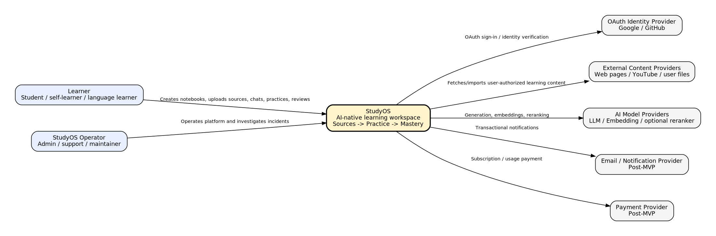

2.4.1 4.1 Actors and External Systems
- Learner: creates notebooks, uploads/links sources, asks questions, completes quizzes, reviews flashcards, saves vocabulary and follows recommendations.
- StudyOS Operator: maintains the platform, monitors queues/cost/errors and investigates operational incidents.
- OAuth providers: authenticate external identities. OAuth is identity proof, not authorization; workspace authorization remains inside StudyOS.
- External content providers: user files, approved web pages and YouTube metadata/transcript sources. Their content is always untrusted data.
- AI model providers: LLM, embeddings and optional reranking.
- Payment/notification providers: post-MVP integrations, isolated behind outbound ports.

2.4.2 4.2 System Boundary Rule
The browser never receives infrastructure credentials, AI provider keys, RabbitMQ credentials or direct database access. All business authorization decisions are server-side.

2.5 5. C4 Level 2 - Containers
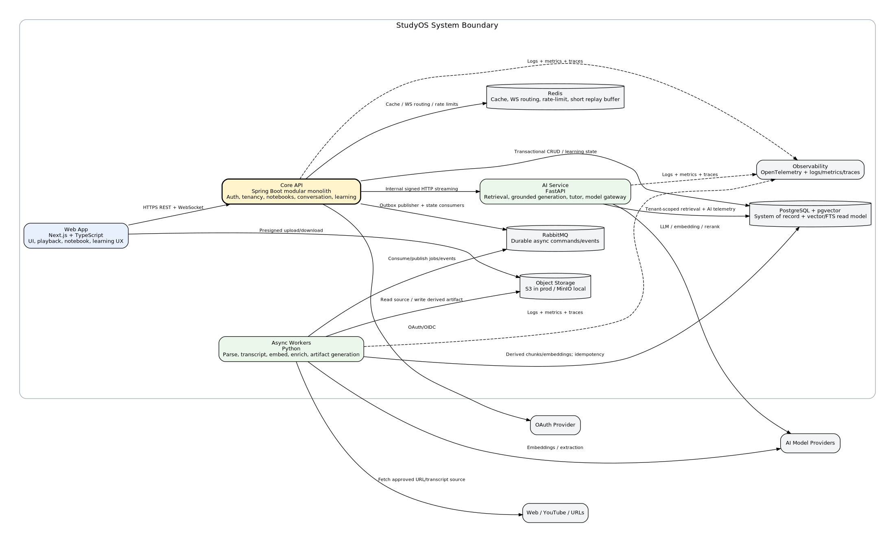

2.5.1 5.1 Web App - Next.js + TypeScript
Responsibilities:
- Authentication UX, notebook/source management and learning workflows.
- WebSocket client with reconnect/resume/dedup logic.
- PDF/web/video citation navigation.
- Transcript playback and Language Lab UI.
- Quiz/flashcard/review UX.
- Client-side optimistic updates only where server remains authoritative.
The Web App may upload directly to S3/MinIO using short-lived presigned URLs issued by Core API. It must not infer successful ingestion from upload completion; source readiness is server state.

2.5.2 5.2 Core API - Spring Boot Modular Monolith
The Core API owns business truth:
- identity/session lifecycle;
- workspaces, membership and RBAC;
- notebooks and source state machine;
- conversations and final message persistence;
- notes;
- artifact job lifecycle;
- quiz attempts/scoring;
- flashcard review records;
- mastery evidence and learning state;
- usage/quota enforcement;
- audit log and transactional outbox.
It is also the public WebSocket gateway. Browser connections terminate here so authorization, quotas, persistence and conversation state remain in one security boundary.

2.5.3 5.3 AI Service - FastAPI
The AI service owns AI computation, not business authorization:
- hybrid retrieval and reranking;
- context construction;
- model routing;
- grounded generation;
- citation validation;
- tutor modes;
- structured language analysis;
- AI evaluation hooks.
Every internal AI request contains a signed tenant context produced by Core API. The AI service validates the internal service token and still applies mandatory workspace/notebook/source filters to retrieval.

2.5.4 5.4 Async Workers - Python
Workers perform long-running or provider-bound work:
- parse/normalize source;
- transcript acquisition and segmentation;
- chunk/embed/index;
- concept extraction/enrichment;
- quiz/flashcard/study-guide generation.
Workers are independently scalable by queue. Worker outputs are idempotent. Business state changes are communicated as events and applied by Core API consumers, while derived chunk/vector data may be written by the responsible AI-data worker using a restricted DB role.

2.5.5 5.5 PostgreSQL + pgvector
Single source of truth and initial retrieval store. The design intentionally colocates relational metadata, full-text search and vectors to reduce early operational overhead. Split retrieval storage only after measured bottlenecks justify it.

2.5.6 5.6 Redis
Use Redis only for ephemeral/distributed coordination:
- rate-limit counters;
- WebSocket node routing/presence;
- short-lived stream replay buffer;
- selected caches;
- short locks where correctness is still enforced by durable storage.
Do not rely on Redis as the only store for messages, source status, mastery or review history.

2.5.7 5.7 RabbitMQ
RabbitMQ handles durable asynchronous workflows. It is not the primary business datastore. Messages are at-least-once and consumers must be idempotent.

2.5.8 5.8 Object Storage
Original uploads and large normalized artifacts are stored in S3/MinIO. Access uses short-lived signed URLs and server-side authorization.

2.6 6. C4 Level 3 - Core Backend Components
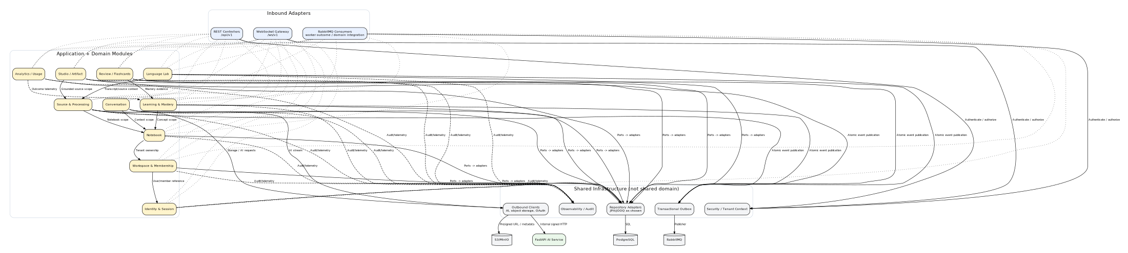

2.6.1 6.1 Dependency Direction
Within each Spring module use the rule:
api/inbound -> application -> domain <- infrastructure/outbound
Domain code must not depend on Spring MVC, JPA, RabbitMQ, S3 SDK or AI provider clients. Infrastructure implements domain/application ports.

2.6.2 6.2 Module Communication
Preferred order:
- same-module direct application call;
- cross-module application interface when synchronous consistency is required;
- local domain/application event for decoupled in-process reactions;
- transactional outbox + RabbitMQ for asynchronous cross-process reactions.
Forbidden:
- one module directly using another module's repository;
- controllers bypassing application services;
- AI worker directly changing a user's mastery score;
- retrieval queries without explicit tenant scope.

2.7 7. C4 Level 3 - AI Service Components
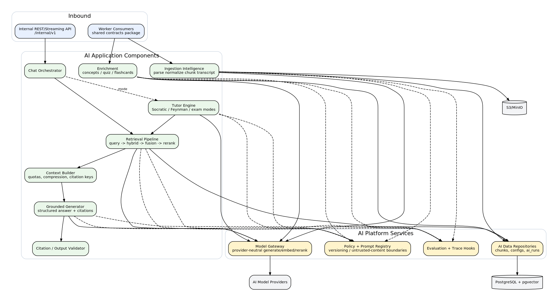

2.7.1 7.1 Chat Pipeline
Chat Orchestrator -> Retrieval -> Context Builder -> Grounded Generator -> Citation Validator -> Stream
Each step has a versioned configuration and trace span. Retrieval results are assigned stable citation keys (C1..Cn). Model output may reference only keys provided in context. The validator rejects or downgrades unsupported citations before a final grounded response is persisted.

2.7.2 7.2 Tutor Pipeline
Tutor modes use the same retrieval and grounding primitives, plus learner state supplied by Core API. Tutor output cannot directly mutate mastery. It may propose or score an evidence-producing activity, whose result is subsequently validated and persisted by the Learning module.

2.7.3 7.3 Model Gateway
All provider-specific SDKs are hidden behind a model gateway with functions equivalent to:
- generate();
- stream();
- embed();
- optional rerank().
Every call records model, provider, prompt/config version, latency, token usage, retries and trace ID.

2.8 8. Runtime Trust Boundaries

2.8.1 8.1 Browser -> Core API
Untrusted public boundary. Requires access token/session, input validation, rate limiting and workspace authorization.

2.8.2 8.2 Core API -> AI Service
Internal boundary but still authenticated. Use short-lived service JWT/mTLS-compatible design. Internal context carries userId, workspaceId, notebookId, explicit sourceIds, permissions and trace ID.

2.8.3 8.3 Worker -> Database/Object Storage
Workers use dedicated least-privilege credentials. A parse worker does not need permission to mutate workspace membership. An embedding worker should not be able to issue refresh tokens.

2.8.4 8.4 Retrieved Content -> LLM
Treat all retrieved source text as untrusted data. It can supply facts but cannot grant permissions, change system instructions, select tools or disclose secrets.

2.9 9. Data Ownership Matrix
Data | Owner | Other access
User/session/workspace | Core Identity/Workspace | read-only references by other modules
Notebook/source lifecycle | Core Notebook/Source | workers receive IDs and job inputs
Original file | Object Storage, referenced by Source module | workers read via scoped credentials
Normalized sections/chunks/embeddings | AI data pipeline | Core reads metadata; AI retrieval reads scoped chunks
Conversation/messages/citations | Core Conversation | AI produces candidate answer/citations, Core persists final state
Quiz/attempt/answers | Core Quiz/Studio | artifact worker proposes validated questions
Flashcard/reviews | Core Review | AI may generate card content; scheduler is deterministic Core logic
Mastery/evidence | Core Learning | AI/tutor may generate evidence candidates only
AI run telemetry | AI + operational store | Analytics reads aggregated data
Outbox/audit | Core platform | operational tooling only

2.10 10. Consistency Model
Use strong transaction consistency for:
- workspace membership changes;
- source state transition + outbox insertion;
- quiz completion + evidence insertion;
- flashcard review + scheduler state update + evidence insertion;
- final assistant message + citations + usage persistence.
Use eventual consistency for:
- source parsing/indexing/enrichment;
- knowledge concept extraction;
- analytics aggregation;
- generated artifacts;
- recommendation regeneration.

2.11 11. Source Processing State Machine
Canonical states:
CREATED -> UPLOADING -> QUEUED -> PARSING -> NORMALIZED -> CHUNKING -> EMBEDDING -> ENRICHING -> READY
Failure from a processing state moves to FAILED with failureCode, safe user-facing message and retryable flag. Deletion moves through DELETING -> DELETED and must remove/revoke original objects and derived data.
State transitions are persisted and validated. Worker logs alone never define source state.

2.12 12. Chat Consistency and Streaming Strategy
External WebSocket terminates at Core API. Core API:
- validates socket token and conversation access;
- persists user message using requestId as idempotency key;
- sends a signed internal streaming request to FastAPI;
- forwards ordered AI events to browser;
- buffers a short replay window in Redis;
- on completion, persists assistant message/citations/usage transactionally;
- supports reconnect using last received sequence.
If Redis is lost, durable conversation history remains correct. A reconnect may lose only transient partial tokens and can fall back to persisted message state.

2.13 13. Failure and Degradation Strategy
Failure | Expected behavior
LLM provider unavailable | Chat fails with retryable error; notebooks/notes/review remain available
Embedding provider unavailable | Source remains processing/failed; uploaded file is retained for retry
RabbitMQ unavailable | Business mutation commits with outbox record; publisher retries later
Worker crashes after writing chunks | Duplicate delivery is safe through deterministic chunk keys/processed event IDs
Redis unavailable | Disable noncritical cache; WS replay/routing degrades; durable history unaffected
Object storage transient failure | Retry idempotent reads/uploads; source does not falsely become READY
Reranker fails | Fallback to fused retrieval results if configured and trace degradation
Citation validator finds unsupported key | Remove citation and mark answer PARTIAL/INSUFFICIENT; never fabricate source metadata

2.14 14. Scalability Evolution

2.14.1 Stage A - Beta
- 1 Core API instance;
- 1 AI service instance;
- 1 parse/index worker process with low concurrency;
- PostgreSQL/pgvector;
- Redis/RabbitMQ/MinIO via Docker Compose locally, managed equivalents in production.

2.14.2 Stage B - Small Production
- horizontal Core API and AI instances;
- worker pools separated by job class;
- Redis for WS routing;
- managed PostgreSQL, Redis and object storage;
- CDN for static/download traffic;
- queue depth-based worker autoscaling.

2.14.3 Service Extraction Triggers
Split a module only if at least one is demonstrated:
- independent scaling bottleneck;
- materially different availability/SLO;
- independent release/team ownership;
- security/data-isolation requirement;
- database contention that cannot be solved locally;
- measured deployment coupling causing operational cost.

2.15 15. Performance and SLO Design Targets
- Core CRUD p95: < 300 ms excluding external providers.
- Chat TTFT p95 target: < 2 s when upstream model permits; separately record provider latency.
- Source processing success: >= 98% for supported valid sources, excluding external access blocks.
- Core API availability beta target: 99.5% monthly.
- Cross-tenant data access: zero tolerance.
- Queue oldest-message age alert thresholds are job-class-specific.

2.16 16. Deployment Topology
Local:
- Next.js;
- Spring Boot Core;
- FastAPI AI;
- worker process(es);
- PostgreSQL + pgvector;
- Redis;
- RabbitMQ;
- MinIO;
- OpenTelemetry collector optional.
Production baseline: Cloudflare/CDN -> AWS ALB -> ECS/Fargate or EC2 services -> RDS PostgreSQL -> ElastiCache -> S3 -> RabbitMQ managed/controlled broker -> observability backend.
Terraform owns infrastructure. Application images are immutable and versioned by commit SHA.

2.17 17. Architecture Freeze Decisions for Sprint 1
- Use modular monolith for Core API.
- Browser WebSocket terminates at Core API, not directly at FastAPI.
- Use PostgreSQL + pgvector + PostgreSQL FTS for first retrieval store.
- Use RabbitMQ + transactional outbox for source/artifact asynchronous jobs.
- Use presigned object uploads.
- Use application-level tenant authorization with mandatory scope fields; evaluate RLS later as defense-in-depth.
- Use UUID identifiers.
- Public contracts versioned under /api/v1; internal AI contracts under /internal/v1.
- Every distributed call/event propagates traceId and correlation identifiers.

3 StudyOS Phase 0 - ERD & Database Design

3.1 1. Database Design Goals
The schema supports four connected concerns without mixing their ownership:
- Identity and tenancy - users, workspaces, membership and sessions.
- Knowledge ingestion - sources, versions, normalized sections, chunks, transcripts and vector/FTS indexes.
- Learning state - concepts, relations, mastery evidence, goals, recommendations and study sessions.
- Learning activity and AI operations - conversations, citations, quizzes, flashcards, vocabulary, AI run telemetry, audit and outbox.
The relational schema is the primary durable model. JSONB is used for versioned or heterogeneous metadata, but not to avoid modeling core relationships.

3.2 2. Full ERD
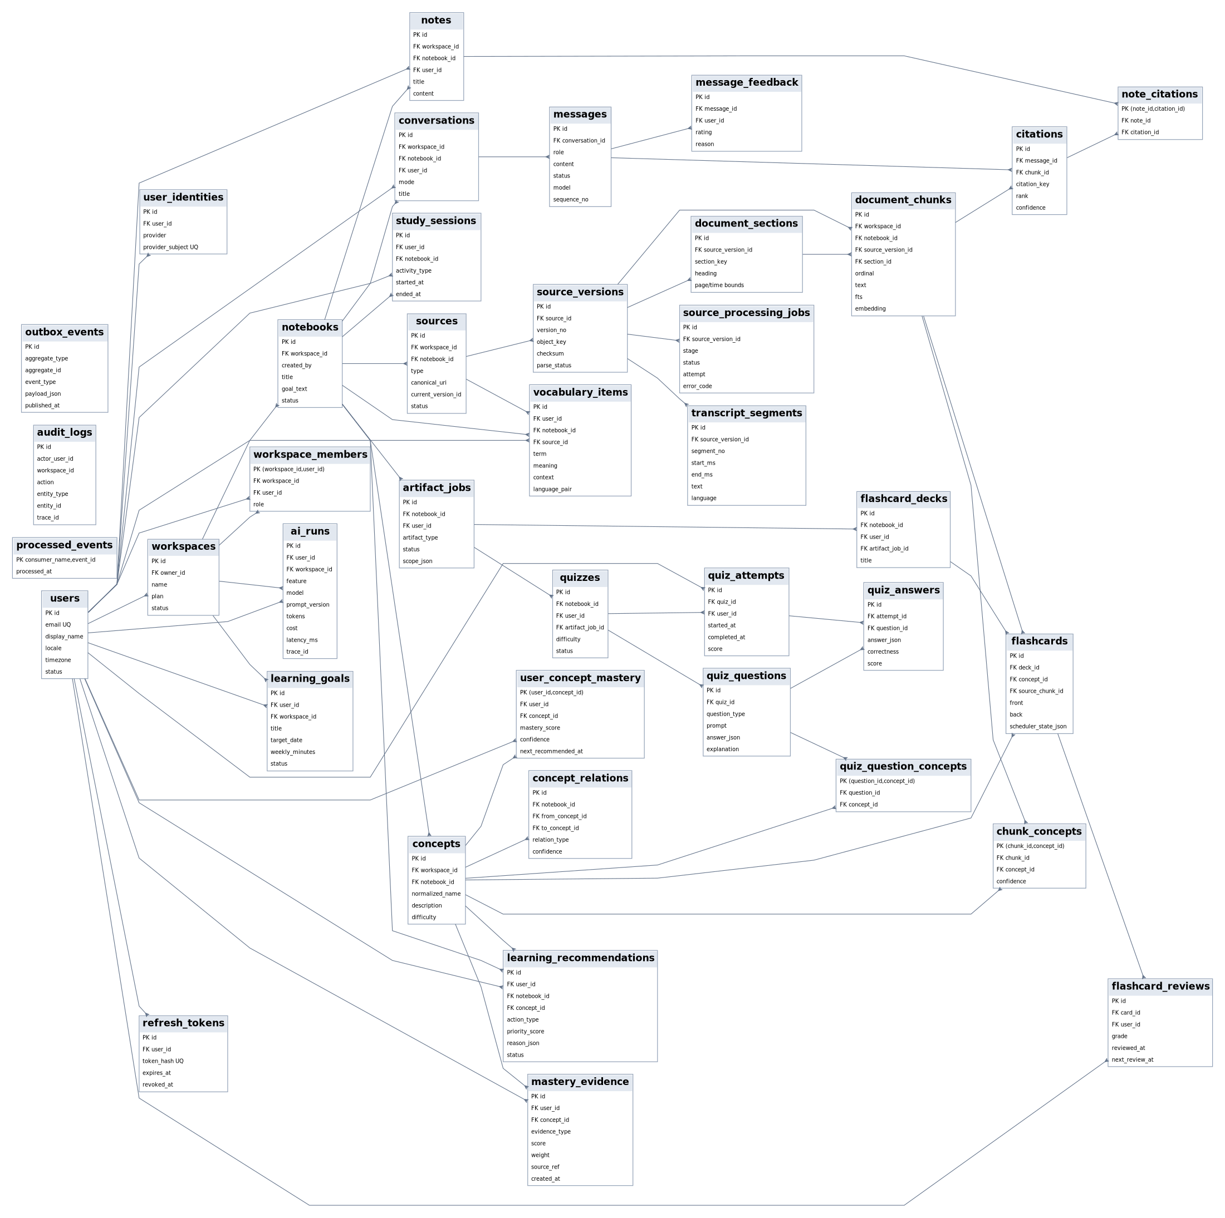
The zoomable SVG source is included in diagrams/erd_full.svg. Complete DDL is included in database/schema.sql.

3.3 3. Domain ERD - Identity & Content
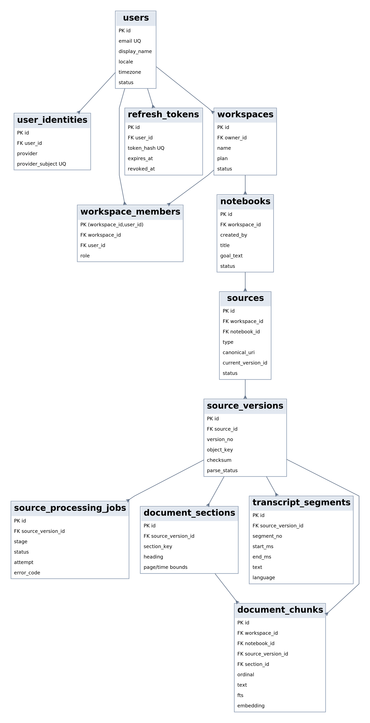

3.3.1 3.1 Identity and Tenancy Tables
Table | Purpose | Important constraints
users | Primary user profile and account status | unique email; soft/deletion workflow at application layer
user_identities | OAuth/OIDC external identities | unique (provider, provider_subject)
refresh_tokens | Rotatable refresh sessions | store token hash only; revocable/expiring
workspaces | Tenant boundary | owner must be a user
workspace_members | Membership and RBAC | composite PK (workspace_id, user_id)
notebooks | Knowledge/learning workspace inside tenant | always belongs to one workspace

3.3.2 3.2 Source and Derived Content Tables
Table | Purpose | Important constraints
sources | Logical source shown to user | contains workspace + notebook scope and current state
source_versions | Immutable version of uploaded/fetched source | unique (source_id, version_no); checksum supports duplicate control
source_processing_jobs | Persisted stage attempt/error metadata | unique (source_version_id, stage)
document_sections | Hierarchical normalized source structure | optional parent section; page/time boundaries
document_chunks | Retrieval unit | mandatory tenant scope; unique deterministic chunk key per version
transcript_segments | Timestamped transcript | ordered and bounded by start/end time

3.4 4. Domain ERD - Learning State
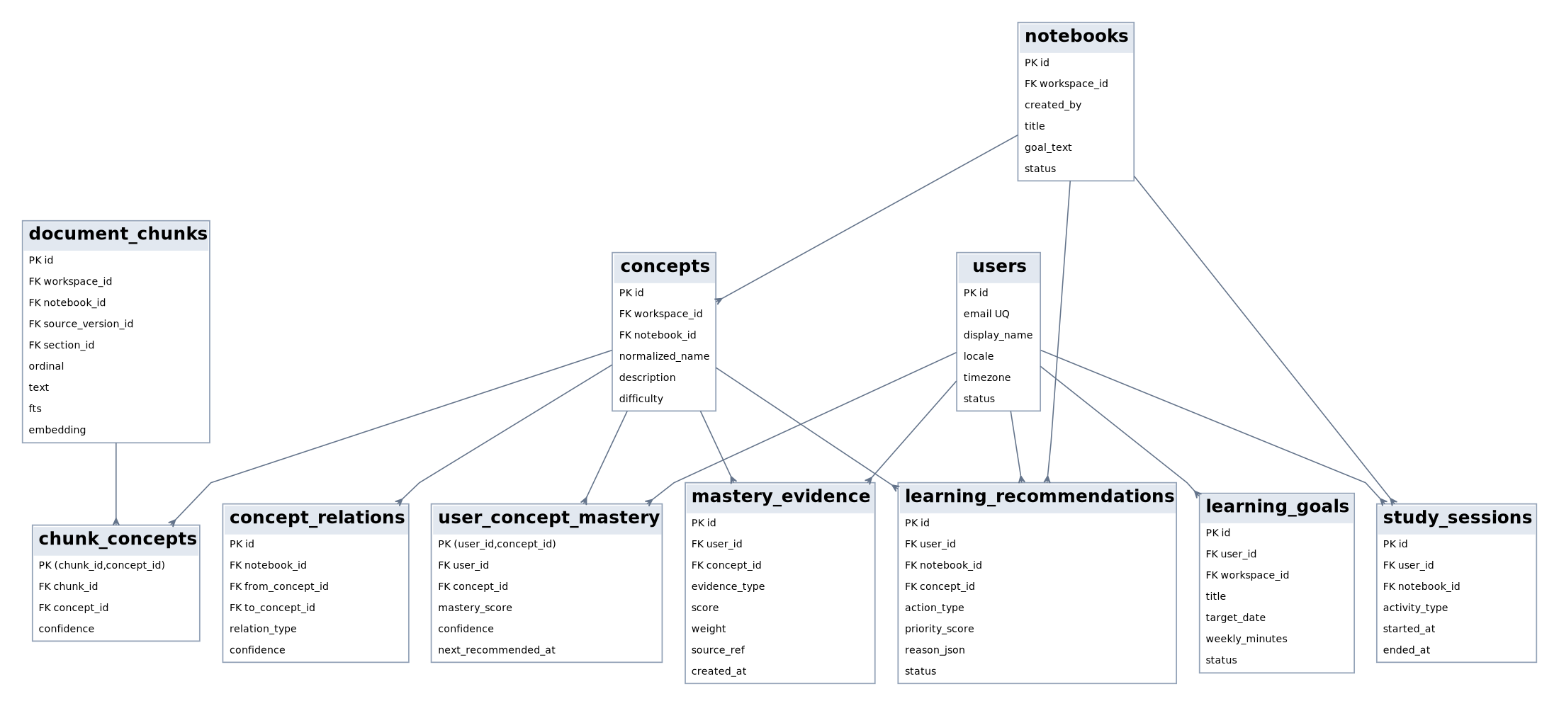

3.4.1 4.1 Concept Model
concepts is notebook-scoped. The same text label in different notebooks is not automatically considered the same concept. This avoids premature global ontology design.
concept_relations supports at least:
- PREREQUISITE;
- PART_OF;
- RELATED_TO;
- CONTRASTS_WITH.
chunk_concepts retains provenance from concept back to supporting chunks.

3.4.2 4.2 Mastery Model
user_concept_mastery is a materialized current state. It must be reproducible/explainable from mastery_evidence history.
Mastery rules:
- reading/viewing alone produces zero or very low-weight evidence;
- quiz, delayed recall and evaluated explanation produce stronger evidence;
- score and confidence are separate;
- AI explanation does not directly increase mastery;
- concurrent mastery updates use optimistic locking via version or transaction-level row lock.

3.5 5. Domain ERD - Practice & Review
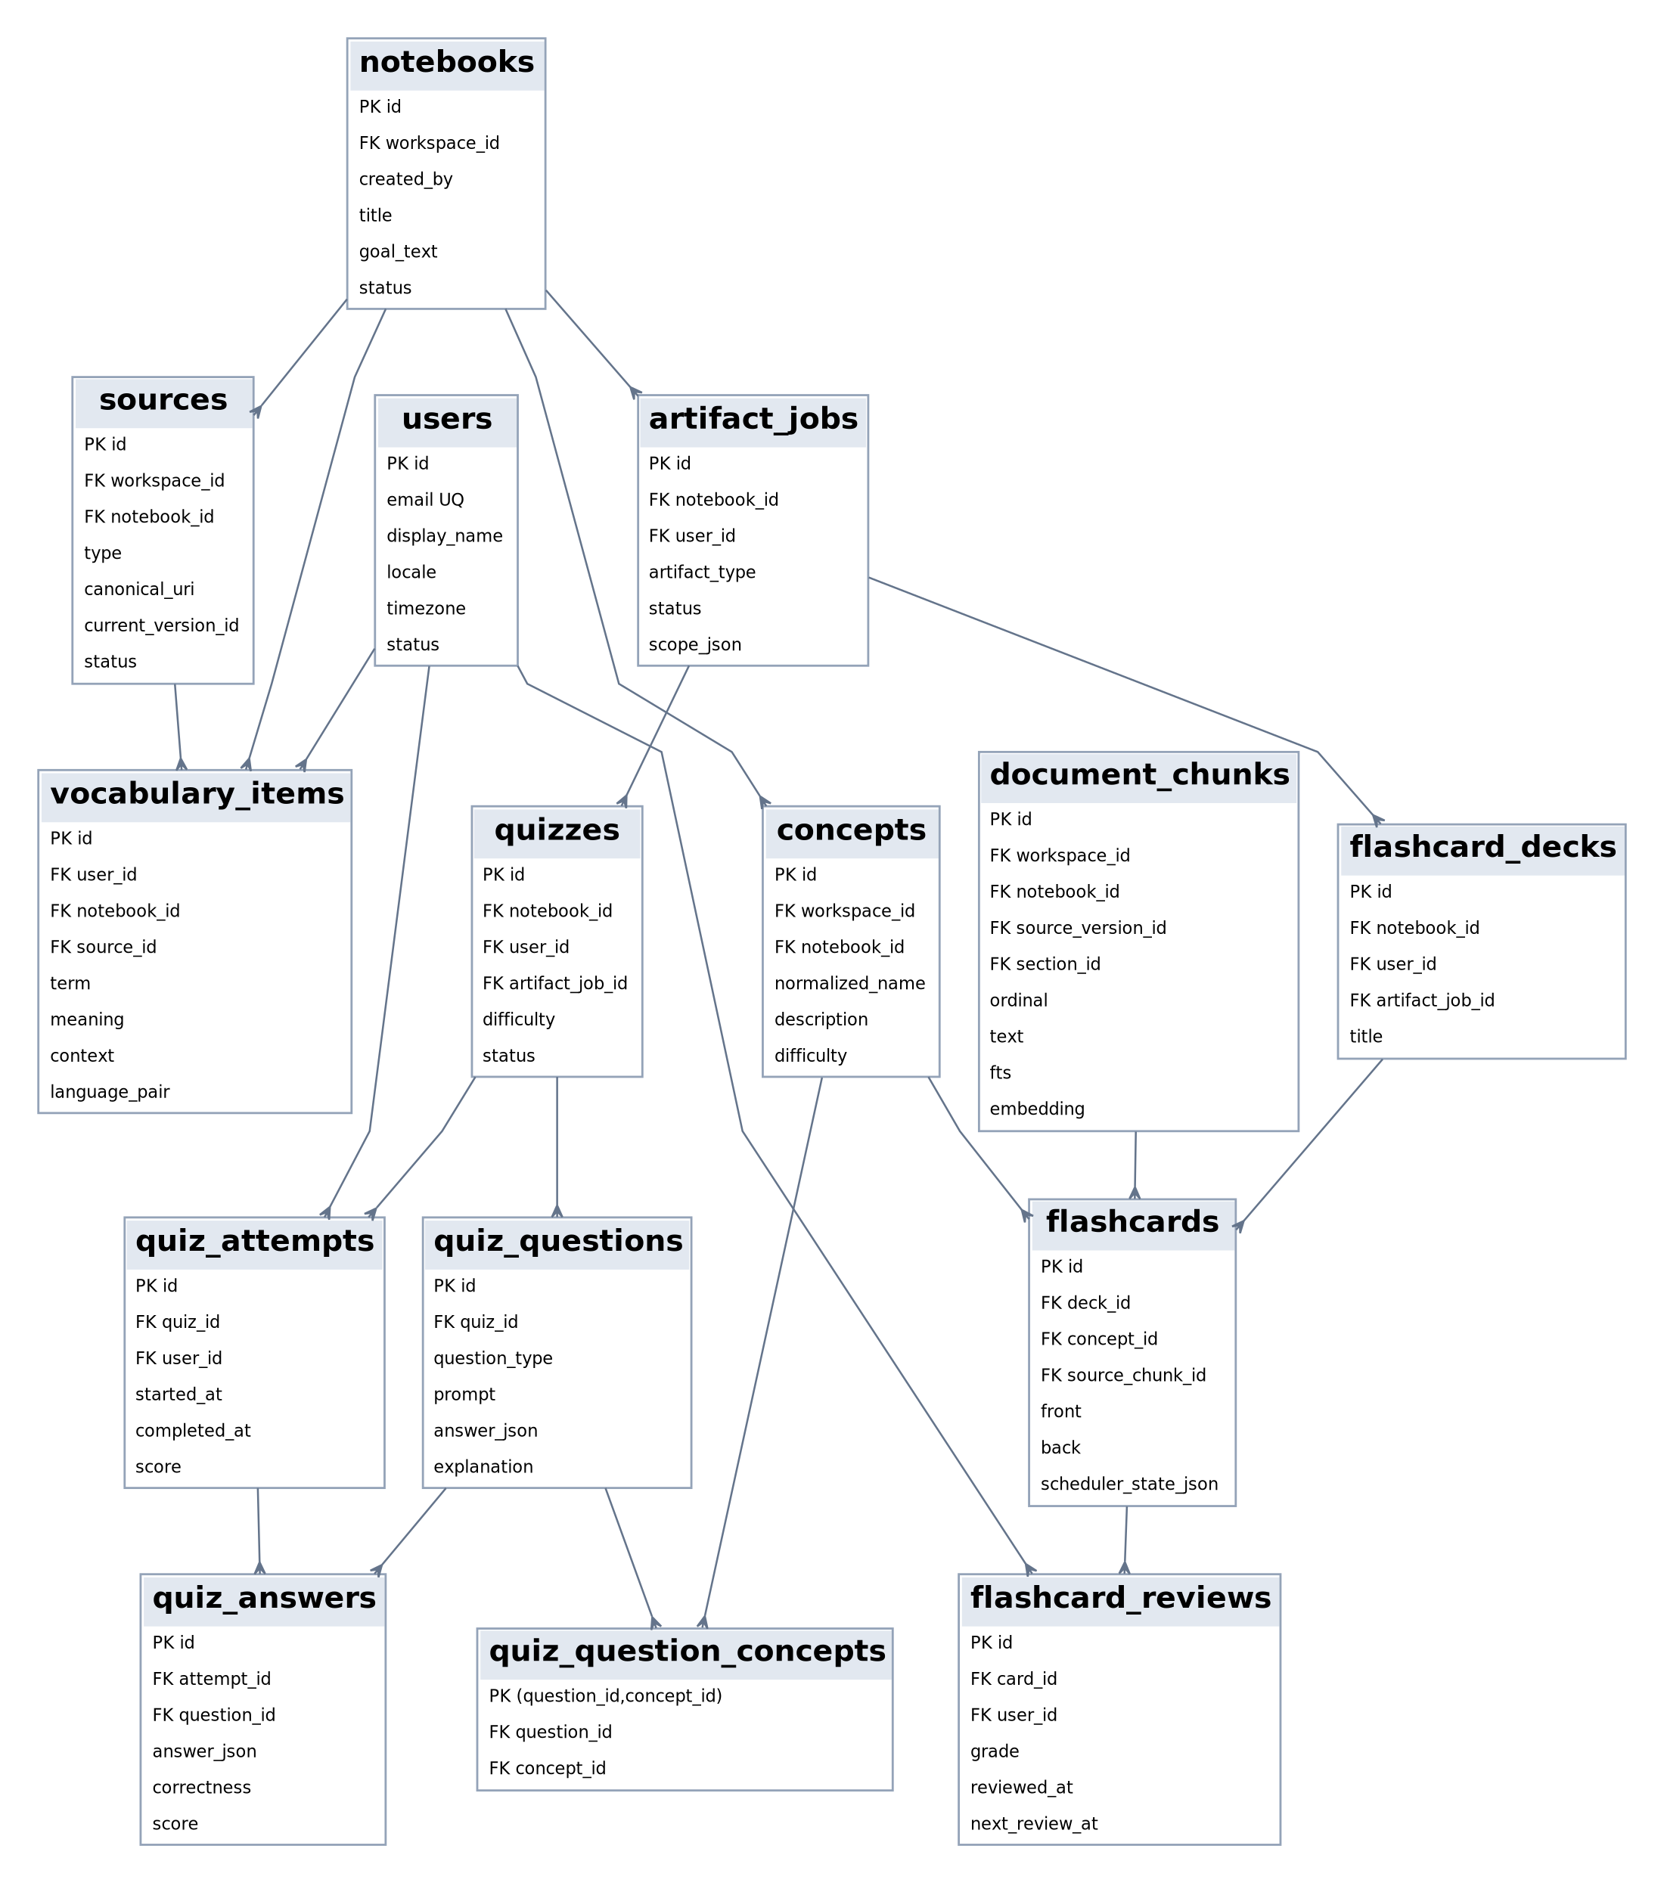

3.5.1 5.1 Artifact Lifecycle
artifact_jobs is the async job aggregate. A quiz or flashcard deck may reference the job that created it, but generated content remains durable after job completion.

3.5.2 5.2 Quiz Tables
- quizzes - quiz aggregate metadata;
- quiz_questions - question content and answer rubric;
- quiz_question_concepts - concept coverage;
- quiz_attempts - one user attempt;
- quiz_answers - saved answer per question.
Completing an attempt is a transactionally meaningful action: validate status -> calculate score -> finalize answers -> generate mastery evidence -> update mastery state -> publish completion event.

3.5.3 5.3 Flashcard Tables
- flashcard_decks - grouping/ownership;
- flashcards - card content, provenance and current scheduler state;
- flashcard_reviews - immutable review history.
The scheduler is deterministic. The review table stores previous/new state for audit and algorithm migration.

3.5.4 5.4 Language Vocabulary
vocabulary_items retains original context and optional transcript segment/source linkage. Creating a flashcard from vocabulary creates a normal reviewable card instead of a separate scheduler implementation.

3.6 6. Domain ERD - Conversation & Operations
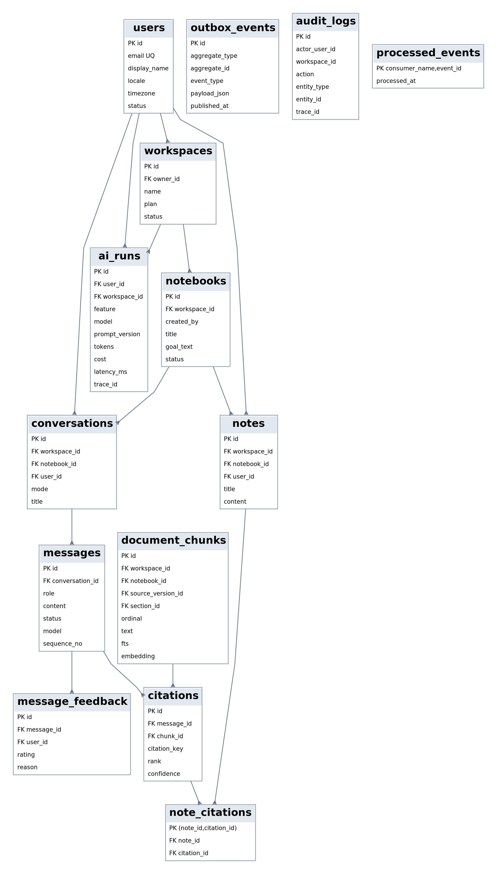

3.6.1 6.1 Conversation and Citation
Messages are ordered by (conversation_id, sequence_no). request_id is unique within a conversation and supports retry/dedup for WebSocket commands.
A citation references a durable document_chunk. User-facing metadata is materialized from chunk/source relationships when serving the response. The model never owns source metadata.

3.6.2 6.2 AI Operations
ai_runs records model/provider usage and performance. It is not used as a source of business truth. Keep raw sensitive prompt content out of this table; store IDs, metrics, config versions and safe evaluation metadata.

3.6.3 6.3 Transactional Outbox
outbox_events is written in the same database transaction as a business mutation. A publisher claims unpublished rows, publishes to RabbitMQ, then records published_at. processed_events supports consumer-level deduplication.

3.7 7. Full Table Catalog

3.7.1 Identity & Tenancy
- users
- user_identities
- refresh_tokens
- workspaces
- workspace_members

3.7.2 Knowledge Workspace & Ingestion
- notebooks
- sources
- source_versions
- source_processing_jobs
- document_sections
- document_chunks
- transcript_segments

3.7.3 Concept & Learning State
- concepts
- concept_relations
- chunk_concepts
- user_concept_mastery
- mastery_evidence
- learning_goals
- learning_recommendations
- study_sessions

3.7.4 Conversation & Knowledge Capture
- conversations
- messages
- citations
- message_feedback
- notes
- note_citations

3.7.5 Active Learning
- artifact_jobs
- quizzes
- quiz_questions
- quiz_question_concepts
- quiz_attempts
- quiz_answers
- flashcard_decks
- flashcards
- flashcard_reviews
- vocabulary_items

3.7.6 Operations
- ai_runs
- audit_logs
- outbox_events
- processed_events

3.8 8. Multi-Tenancy Strategy
Every high-risk retrieval/business table carries or can deterministically resolve a workspace. For retrieval performance and safety, document_chunks explicitly stores both workspace_id and notebook_id even though those can be derived from the source chain.
Mandatory rule: a repository method that returns tenant-owned data must take WorkspaceId/tenant context, or use a repository abstraction that injects it automatically. Do not expose generic findById(UUID) for tenant-owned aggregates without a second authorization step.
Examples:
- safe: findNotebook(workspaceId, notebookId);
- safe: searchChunks(workspaceId, notebookId, sourceIds, queryEmbedding);
- unsafe: findChunk(chunkId) used directly from user input.

3.9 9. Retrieval Index Design

3.9.1 9.1 Full Text
document_chunks.search_vector is a generated tsvector with GIN index. Phase 0 uses the simple configuration to avoid language-specific stemming surprises. Language-specific tuning is an evaluation task, not an initial assumption.

3.9.2 9.2 Vector
document_chunks.embedding uses vector(1536) in the provided baseline DDL. This is an implementation placeholder tied to the first selected embedding model. If the model dimension changes, migrate explicitly; do not silently mix vectors from incompatible models.
Use HNSW cosine index after enough data exists to justify approximate search. Exact search can be retained for small evaluation datasets.

3.9.3 9.3 Scope/Lookup Indexes
Required composite indexes include:
- sources(notebook_id, status, updated_at);
- document_chunks(workspace_id, notebook_id, source_version_id);
- messages(conversation_id, sequence_no);
- mastery_evidence(user_id, concept_id, occurred_at);
- learning_recommendations(user_id, status, priority_score);
- flashcard_reviews(user_id, reviewed_at);
- unpublished outbox_events partial index.

3.10 10. Transaction Boundaries

3.10.1 T1 Create source + queue work
One DB transaction:
- create/update source/version state;
- insert processing job metadata if applicable;
- insert outbox event.
Object upload itself is not in the database transaction. Completion is verified separately before queueing.

3.10.2 T2 Complete quiz
One DB transaction:
- lock/validate attempt is IN_PROGRESS;
- calculate score from persisted answers;
- set attempt COMPLETED;
- insert evidence records;
- update mastery rows with optimistic version/lock;
- insert outbox event.

3.10.3 T3 Grade flashcard review
One DB transaction:
- lock card scheduler state;
- compute deterministic next state;
- append review record;
- update card due/scheduler state;
- append mastery evidence if concept-linked;
- update mastery state;
- outbox learning event.

3.10.4 T4 Persist assistant final result
One DB transaction after stream completes:
- finalize assistant message content/status;
- validate and persist citations;
- persist usage reference/summary;
- emit product telemetry/outbox if required.
Partial streaming tokens are not required to be individually durable.

3.11 11. Idempotency Rules
- Source version uniqueness uses source + checksum/version controls.
- Chunks use deterministic chunk_key unique per source version.
- processed_events(consumer_name,event_id) rejects duplicate consumer handling.
- Artifact generation accepts idempotency_key per user/job request.
- WebSocket user commands use requestId; duplicate sends return/resume the same logical message.
- Quiz attempt completion is state-checked and safe to retry.
- Flashcard review POST should accept a request/idempotency key in the implementation even if the baseline REST example keeps the body minimal.

3.12 12. Delete and Retention Workflow
Deleting a source must eventually remove:
- original/normalized object storage objects;
- source versions/sections/chunks/embeddings/transcript segments;
- dependent chunk-concept edges;
- citations referencing deleted source according to product retention policy;
- generated artifacts whose source dependency becomes invalid, or mark them stale.
User/account deletion requires a separate orchestration workflow because some records may need anonymized operational retention. The exact retention period is a policy decision outside Phase 0.

3.13 13. Migration Strategy
Use Flyway or Liquibase in Core API as the owner of relational schema migrations. If AI workers need schema additions, they are still merged through one migration pipeline to avoid competing owners.
Rules:
- migrations are immutable after release;
- use expand/contract for breaking changes;
- deploy backward-compatible schema before code depending on it;
- add indexes concurrently in production where appropriate;
- never run destructive migrations automatically without backup/rollback plan.

3.14 14. Database Deliverables
- database/schema.sql - PostgreSQL baseline with PK/FK, constraints and indexes.
- database/studyos.dbml - modeling/import source.
- diagrams/erd_full.svg - complete zoomable relationship diagram.
- Four domain-specific ERD views for easier review.

4 StudyOS Phase 0 - Module & Package Structure

4.1 1. Repository Strategy
Use a monorepo initially because one developer/small team owns the product and contract changes across frontend, Core API, AI service and workers are frequent.
studyos/
├── apps/
│ ├── web/ # Next.js + TypeScript
│ ├── core-api/ # Spring Boot modular monolith
│ ├── ai-service/ # FastAPI internal AI API
│ └── worker/ # RabbitMQ worker entry points
├── packages/
│ ├── contracts/ # generated/shared OpenAPI/JSON schemas where practical
│ ├── ui/ # optional shared web UI package
│ └── python-ai-core/ # shared AI primitives used by ai-service + workers
├── infrastructure/
│ ├── docker/
│ ├── terraform/
│ └── observability/
├── database/
│ └── migrations/
├── docs/
│ ├── adr/
│ ├── architecture/
│ └── runbooks/
├── tests/
│ ├── e2e/
│ ├── load/
│ └── security/
├── .github/workflows/
├── docker-compose.yml
└── README.md

4.2 2. Spring Boot Core API Package Structure
Base package: com.studyos.
Each business module follows a local clean/hexagonal structure. Avoid one giant global controller/service/repository/entity layout.
apps/core-api/src/main/java/com/studyos/
├── StudyOsApplication.java
├── identity/
│ ├── api/
│ │ ├── AuthController.java
│ │ ├── MeController.java
│ │ └── dto/
│ ├── application/
│ │ ├── AuthApplicationService.java
│ │ ├── command/
│ │ ├── query/
│ │ └── port/
│ ├── domain/
│ │ ├── User.java
│ │ ├── RefreshSession.java
│ │ ├── UserRepository.java
│ │ └── event/
│ └── infrastructure/
│ ├── persistence/
│ ├── oauth/
│ └── security/
├── workspace/
├── notebook/
├── source/
├── conversation/
├── studio/
├── learning/
├── review/
├── language/
├── analytics/
├── admin/
└── shared/
├── kernel/
├── security/
├── persistence/
├── outbox/
├── messaging/
├── observability/
├── web/
└── testing/

4.3 3. Spring Module Responsibilities

4.3.1 3.1 identity
Owns:
- registration/login/logout;
- password hashing;
- OAuth identity linking;
- access/refresh token lifecycle;
- current user profile.
Does not own workspace roles. Identity proves who the caller is; Workspace decides what the caller may access.
Suggested classes:
identity/api/AuthController
identity/application/AuthApplicationService
identity/application/RefreshTokenService
identity/domain/User
identity/domain/UserIdentity
identity/domain/RefreshSession
identity/domain/UserRepository
identity/infrastructure/persistence/JpaUserRepositoryAdapter
identity/infrastructure/security/JwtTokenService

4.3.2 3.2 workspace
Owns:
- workspace aggregate;
- membership;
- roles and permission checks;
- membership queries used by other modules through a narrow application interface.
Key port:
public interface WorkspaceAuthorization {
void requireMember(UserId userId, WorkspaceId workspaceId);
void requireRole(UserId userId, WorkspaceId workspaceId, WorkspaceRole... roles);
}

4.3.3 3.3 notebook
Owns notebook metadata, archival and user-visible learning goal text associated with a notebook. It does not own source processing.

4.3.4 3.4 source
Owns:
- source aggregate and version lifecycle;
- upload-init/upload-complete;
- checksum and MIME/size validation;
- source processing state machine;
- retry/delete commands;
- source outbox events;
- processing status projection.
Important domain objects:
Source
SourceVersion
SourceProcessingState
SourceType
SourceFailure
SourceRepository
ObjectStoragePort
SourceEventPublisher (implemented via outbox)

4.3.5 3.5 conversation
Owns:
- conversation aggregate;
- message persistence and sequence numbers;
- WebSocket session authorization;
- short-lived WS token issuance;
- AI stream orchestration from the Core side;
- final citation persistence;
- user feedback.
It does not implement vector retrieval or prompt logic.

4.3.6 3.6 studio
Owns async learning artifact jobs and durable generated quiz/flashcard/study-guide aggregates. Generation is delegated to workers/AI service; Core validates and persists resulting artifacts.

4.3.7 3.7 learning
Owns:
- concepts as product-visible learning entities;
- concept relations accepted into the notebook;
- mastery evidence;
- user mastery state;
- learning goals;
- recommendations.
Recommended application services:
MasteryEvidenceService
MasteryProjectionService
LearningRecommendationService
ConceptApplicationService
LearningGoalApplicationService

4.3.8 3.8 review
Owns flashcard scheduling and review lifecycle. Scheduler implementation is a domain service with deterministic tests and no LLM dependency.
public interface ReviewScheduler {
ReviewScheduleResult schedule(CardScheduleState previous, ReviewGrade grade, Instant reviewedAt);
}

4.3.9 3.9 language
Owns saved vocabulary and user-facing language learning actions. It calls AI Service for sentence analysis but persists vocabulary and card creation through Core modules.

4.3.10 3.10 analytics
Owns product/learning read models and aggregation queries. It should not become a dumping ground for domain logic. Its data is derived from durable operational tables and emitted events.

4.3.11 3.11 admin
Post-beta operations endpoints: source failures, queue summaries, AI usage/cost and user support actions. All admin actions are audited.

4.4 4. Shared Package Rules
shared contains technical cross-cutting capabilities, not generic business entities.
Allowed:
- TenantContext;
- ApiError;
- Clock abstraction;
- tracing helpers;
- outbox infrastructure;
- pagination types;
- JSON/object mapper configuration;
- security filters.
Avoid:
- CommonService;
- BaseEntity with unrelated domain behavior;
- cross-module DTO dumping;
- globally shared JPA repositories.

4.5 5. Dependency Enforcement
Use ArchUnit tests to fail the build when boundaries are violated.
Example rules:
..domain.. may depend only on java.*, approved shared kernel types and same module domain.
..application.. may depend on same module domain and application ports.
..api.. may depend on application, never persistence adapters.
..infrastructure.. may implement ports and depend on frameworks.
One module's infrastructure package may not be imported by another module.
Cross-module calls should target explicit public application interfaces such as:
WorkspaceAuthorization
NotebookLookup
LearningEvidenceGateway
ReviewCardCreation

4.6 6. Suggested Core API Layer Example - Source Module
source/
├── api/
│ ├── SourceController.java
│ ├── SourceStatusController.java
│ └── dto/
│ ├── UploadInitRequest.java
│ ├── UploadInitResponse.java
│ └── SourceResponse.java
├── application/
│ ├── SourceApplicationService.java
│ ├── SourceStateTransitionService.java
│ ├── command/
│ │ ├── InitializeUpload.java
│ │ ├── CompleteUpload.java
│ │ ├── CreateUrlSource.java
│ │ └── RetrySource.java
│ ├── query/
│ │ └── SourceQueryService.java
│ └── port/
│ ├── ObjectStoragePort.java
│ └── SourceProcessingPublisher.java
├── domain/
│ ├── Source.java
│ ├── SourceVersion.java
│ ├── SourceStatus.java
│ ├── SourceType.java
│ ├── SourceRepository.java
│ ├── SourcePolicy.java
│ └── event/
└── infrastructure/
├── persistence/
├── storage/
├── messaging/
└── config/

4.7 7. FastAPI AI Service Structure
apps/ai-service/
├── app/
│ ├── main.py
│ ├── api/
│ │ ├── dependencies.py
│ │ └── v1/
│ │ ├── chat.py
│ │ ├── retrieval.py
│ │ ├── artifacts.py
│ │ ├── language.py
│ │ └── health.py
│ ├── core/
│ │ ├── config.py
│ │ ├── logging.py
│ │ ├── security.py
│ │ ├── exceptions.py
│ │ └── telemetry.py
│ ├── contracts/
│ │ ├── internal_context.py
│ │ ├── chat.py
│ │ ├── citations.py
│ │ └── artifacts.py
│ ├── retrieval/
│ │ ├── query_normalizer.py
│ │ ├── vector_search.py
│ │ ├── lexical_search.py
│ │ ├── fusion.py
│ │ ├── reranker.py
│ │ ├── context_builder.py
│ │ └── citation_validator.py
│ ├── generation/
│ │ ├── grounded_answer.py
│ │ ├── stream_events.py
│ │ └── structured_output.py
│ ├── tutor/
│ │ ├── service.py
│ │ ├── socratic.py
│ │ ├── feynman.py
│ │ ├── exam.py
│ │ └── state.py
│ ├── artifacts/
│ │ ├── quiz_generator.py
│ │ ├── flashcard_generator.py
│ │ └── study_guide_generator.py
│ ├── language/
│ │ ├── analyzer.py
│ │ └── schemas.py
│ ├── model_gateway/
│ │ ├── base.py
│ │ ├── router.py
│ │ ├── providers/
│ │ └── usage.py
│ ├── prompts/
│ │ ├── registry.py
│ │ └── versions/
│ ├── repositories/
│ │ ├── chunks.py
│ │ ├── ai_runs.py
│ │ └── configs.py
│ └── evaluation/
│ ├── datasets.py
│ ├── retrieval_metrics.py
│ └── answer_metrics.py
├── tests/
│ ├── unit/
│ ├── integration/
│ ├── eval/
│ └── security/
├── pyproject.toml
└── Dockerfile

4.8 8. AI Service Dependency Rules
- API routes validate request shape and internal auth, then call application components.
- Retrieval code never trusts sourceIds without tenant context.
- Provider SDKs appear only under model_gateway/providers.
- Prompt templates are versioned and loaded through registry; no large inline prompts scattered through routes.
- Citation validator is mandatory for grounded mode.
- AI code may propose structured results but cannot directly bypass Core business rules.
- Evaluation code is reusable in CI/offline scripts and not embedded only in notebooks.

4.9 9. Worker Package Structure
Use one worker application with independently selectable consumer groups at first.
apps/worker/
├── worker/
│ ├── main.py
│ ├── messaging/
│ │ ├── connection.py
│ │ ├── consumer.py
│ │ ├── publisher.py
│ │ └── idempotency.py
│ ├── consumers/
│ │ ├── parse_source.py
│ │ ├── fetch_transcript.py
│ │ ├── index_source.py
│ │ ├── enrich_source.py
│ │ └── generate_artifact.py
│ ├── ingestion/
│ │ ├── parsers/
│ │ ├── normalization/
│ │ ├── chunking/
│ │ └── transcript/
│ └── adapters/
│ ├── postgres.py
│ ├── object_storage.py
│ └── ai_client.py
└── tests/
Deployment can select consumers with environment variables such as:
WORKER_QUEUES=q.source.parse.v1,q.source.transcript.v1
Later split Docker services by workload without changing package ownership.

4.10 10. Frontend Structure
Although not the core of Phase 0, frontend boundaries should match backend concepts.
apps/web/src/
├── app/
├── features/
│ ├── auth/
│ ├── workspace/
│ ├── notebook/
│ ├── sources/
│ ├── chat/
│ ├── notes/
│ ├── quiz/
│ ├── review/
│ ├── learning/
│ └── language-lab/
├── entities/
├── shared/
│ ├── api/
│ ├── ws/
│ ├── ui/
│ └── lib/
└── tests/
Generate REST client types from OpenAPI where practical. WebSocket events use a generated/validated schema from the protocol contract.

4.11 11. Configuration Separation
Common environment groups:

4.11.1 Core API
DATABASE_URL
REDIS_URL
RABBITMQ_URL
JWT_ISSUER
JWT_SIGNING_KEY / key reference
AI_INTERNAL_URL
AI_SERVICE_AUDIENCE
S3_BUCKET
S3_REGION
OTEL_EXPORTER_OTLP_ENDPOINT

4.11.2 AI Service
DATABASE_READ_URL
MODEL_PROVIDER_* credentials
EMBEDDING_MODEL
RERANKER_MODEL
PROMPT_REGISTRY_PATH
INTERNAL_JWT_AUDIENCE
OTEL_EXPORTER_OTLP_ENDPOINT

4.11.3 Worker
RABBITMQ_URL
DATABASE_DERIVED_DATA_URL
S3_BUCKET
WORKER_QUEUES
CONCURRENCY
MAX_ATTEMPTS
AI_INTERNAL_URL
Secrets are injected at runtime and never committed.

4.12 12. Testing Package Strategy

4.12.1 Core
unit: domain rules, state machines, scheduler, mastery updates
slice: controller/serialization/security slices
integration: Testcontainers PostgreSQL/RabbitMQ/MinIO-compatible integration
architecture: ArchUnit
contract: OpenAPI response/request compatibility

4.12.2 AI
unit: fusion, context budgeting, citation validation, provider routing
integration: pgvector retrieval and model-provider fake server
security: cross-tenant filters and indirect prompt injection corpus
eval: versioned retrieval/answer datasets

4.12.3 E2E
Playwright covers the production-critical vertical slice: register -> notebook -> source -> READY -> chat/citation -> quiz -> mastery -> review.

4.13 13. Coding Conventions to Freeze
- Java 21 baseline unless project environment requires another LTS.
- Python 3.12 baseline unless a dependency requires otherwise.
- TypeScript strict mode.
- UUID IDs serialized as strings.
- API JSON camelCase; database snake_case; Python internal schemas snake_case or explicit aliases consistently.
- UTC timestamps in storage/API; user timezone applied only for presentation/scheduling decisions.
- Money/cost values use decimal, never binary float for persisted billing amounts.
- No domain decision based on client-provided role/workspace ownership claims.

4.14 14. Definition of an Implemented Module
A module is not considered complete until it has:
- public application interface;
- authorization rule;
- domain invariants;
- persistence adapter;
- API/event contract where applicable;
- tests including negative/unauthorized paths;
- tracing/metrics;
- migration/index review;
- no forbidden dependency violations.

5 StudyOS Phase 0 - REST & Internal OpenAPI Contract

5.1 1. Contract Strategy
StudyOS uses contract-first APIs. The browser-facing Core API and the internal AI API have separate OpenAPI specifications because they serve different trust boundaries and release semantics.
Deliverables:
- contracts/openapi-core.yaml - browser/public application REST contract.
- contracts/openapi-ai-internal.yaml - service-to-service Core -> FastAPI contract.
The WebSocket protocol is specified separately because OpenAPI does not model the long-lived bidirectional stream adequately for this design.

5.2 2. API Versioning
Public base path: /api/v1. Internal base path: /internal/v1.
Rules:
- additive optional response fields do not require a new major API version;
- renaming/removing fields or changing semantics requires migration/deprecation;
- event contracts version in the routing key/name (*.v1);
- internal AI contract still follows explicit versioning even though it is not public.

5.3 3. Authentication and Authorization
Browser-facing API uses bearer access tokens. Refresh tokens are rotated and stored as hashes server-side. OAuth sign-in resolves to the same internal user/session model.
Authorization is never inferred from object IDs alone. Each request resolving a tenant-owned resource must prove the current user is authorized for the resource's workspace.
Internal AI API uses a separate service credential/JWT with audience restrictions. The payload additionally carries explicit tenant context; this context narrows data access but does not replace service authentication.

5.4 4. API Conventions
- JSON field names: camelCase.
- IDs: UUID strings.
- Time: ISO-8601 UTC timestamps.
- Large collections: cursor pagination.
- Deletes: 204 for synchronous metadata deletion; 202 where derived/object cleanup is asynchronous.
- Async creation: return a Job or resource with processing state.
- Errors: stable machine-readable code, human-readable message, traceId, optional details.
Canonical error:
{
"code": "SOURCE_NOT_READY",
"message": "Source is still processing.",
"traceId": "4df4683339c44be9a31b036ce57d9e3f",
"details": {
"sourceId": "...",
"currentStage": "EMBEDDING"
}
}

5.5 5. Idempotency
Endpoints that may be retried across network failures should support an Idempotency-Key request header in implementation even where the baseline YAML keeps the schema concise.
Required idempotent operations:
- upload complete;
- retry source;
- artifact generation;
- quiz attempt complete;
- flashcard review submission;
- any payment operation later.
For WebSocket chat, requestId is the idempotency key.

5.6 6. Core Endpoint Catalog
The generated OpenAPI currently defines 46 paths. The following matrix groups them by capability.

5.6.1 6.1 Auth
Method | Path | Purpose
POST | /api/v1/auth/register | Create account
POST | /api/v1/auth/login | Email/password sign in
POST | /api/v1/auth/refresh | Rotate refresh token
POST | /api/v1/auth/logout | Revoke refresh session
GET | /api/v1/me | Current user

5.6.2 6.2 Workspace & Notebook
Method | Path | Purpose
GET/POST | /api/v1/workspaces | List/create workspace
GET/PATCH/DELETE | /api/v1/workspaces/{workspaceId} | Manage workspace
GET | /api/v1/workspaces/{workspaceId}/members | Membership view
GET/POST | /api/v1/workspaces/{workspaceId}/notebooks | List/create notebook
GET/PATCH/DELETE | /api/v1/notebooks/{notebookId} | Manage notebook

5.6.3 6.3 Source Ingestion
Method | Path | Purpose
GET | /api/v1/notebooks/{notebookId}/sources | List sources
POST | /api/v1/notebooks/{notebookId}/sources/upload-init | Validate metadata and issue presigned upload
POST | /api/v1/notebooks/{notebookId}/sources/upload-complete | Confirm object, queue processing
POST | /api/v1/notebooks/{notebookId}/sources/url | Add WEB/YOUTUBE source
POST | /api/v1/notebooks/{notebookId}/sources/raw | Add raw text
GET | /api/v1/sources/{sourceId} | Source metadata
GET | /api/v1/sources/{sourceId}/status | Detailed processing status
POST | /api/v1/sources/{sourceId}/retry | Retry a retryable failure
DELETE | /api/v1/sources/{sourceId} | Async source/dependency deletion
GET | /api/v1/sources/{sourceId}/transcript | Timestamped transcript

5.6.4 6.4 Conversation
Method | Path | Purpose
POST | /api/v1/notebooks/{notebookId}/conversations | Create conversation/mode
GET | /api/v1/conversations/{conversationId} | Conversation metadata
GET | /api/v1/conversations/{conversationId}/messages | Durable message history
POST | /api/v1/conversations/{conversationId}/ws-token | Short-lived socket token
POST | /api/v1/messages/{messageId}/feedback | Quality feedback
Actual AI generation happens over WebSocket after the conversation is created.

5.6.5 6.5 Notes
Method | Path | Purpose
GET/POST | /api/v1/notebooks/{notebookId}/notes | List/create note
GET/PATCH/DELETE | /api/v1/notes/{noteId} | Note lifecycle

5.6.6 6.6 Studio/Artifacts
Method | Path | Purpose
POST | /api/v1/notebooks/{notebookId}/artifacts/quiz | Async quiz generation
POST | /api/v1/notebooks/{notebookId}/artifacts/flashcards | Async flashcard generation
POST | /api/v1/notebooks/{notebookId}/artifacts/study-guide | Async study guide generation
GET | /api/v1/jobs/{jobId} | Async job status

5.6.7 6.7 Quiz
Method | Path | Purpose
GET | /api/v1/quizzes/{quizId} | Get quiz content
POST | /api/v1/quizzes/{quizId}/attempts | Start attempt
POST | /api/v1/attempts/{attemptId}/answers | Save/replace answer
POST | /api/v1/attempts/{attemptId}/complete | Finalize score + mastery evidence
GET | /api/v1/attempts/{attemptId} | Result

5.6.8 6.8 Review
Method | Path | Purpose
GET | /api/v1/review/queue | Due cards for current user
POST | /api/v1/flashcards/{cardId}/reviews | Grade recall and schedule next review

5.6.9 6.9 Learning
Method | Path | Purpose
GET | /api/v1/notebooks/{notebookId}/concepts | Concept nodes/relationships projection
GET | /api/v1/notebooks/{notebookId}/mastery | Current mastery state
GET | /api/v1/learning/recommendations | Explainable next actions
GET/POST | /api/v1/learning/goals | Goal lifecycle
PATCH | /api/v1/learning/goals/{goalId} | Update/pause/complete goal

5.6.10 6.10 Language Lab
Method | Path | Purpose
POST | /api/v1/language/analyze | Translate/analyze sentence/segment
GET/POST | /api/v1/vocabulary/items | Vocabulary library

5.6.11 6.11 Analytics
Method | Path | Purpose
GET | /api/v1/analytics/overview | User learning overview
GET | /api/v1/analytics/notebooks/{notebookId} | Notebook metrics

5.7 7. Source Upload Contract
Recommended flow:

5.7.1 Step 1 - Initialize
POST /api/v1/notebooks/{notebookId}/sources/upload-init
Request:
{
"fileName": "ddia.pdf",
"mimeType": "application/pdf",
"sizeBytes": 42188910,
"checksumSha256": null
}
Server actions:
- authorize notebook;
- validate plan file limits/MIME;
- create Source + SourceVersion in UPLOADING;
- issue short-lived object upload URL.

5.7.2 Step 2 - Browser uploads object
Browser PUTs bytes to object storage. This does not mean the source is ready.

5.7.3 Step 3 - Complete
POST /api/v1/notebooks/{notebookId}/sources/upload-complete
Server verifies metadata/object existence where configured, transitions to QUEUED and inserts outbox event atomically.

5.8 8. Async Job Contract
Long-running artifact generation returns 202 Accepted with:
{
"id": "job-uuid",
"type": "QUIZ",
"status": "PENDING",
"progress": 0,
"resultRef": null,
"errorCode": null
}
Client may poll /jobs/{jobId} initially. Later, product event push can update jobs over WebSocket without changing job semantics.

5.9 9. Internal AI API
The AI service is not browser-facing.

5.9.1 9.1 /internal/v1/chat/stream
Input includes:
- signed InternalContext;
- conversation/message IDs;
- user query;
- mode;
- conversation summary;
- learner/mastery context.
Output is streaming NDJSON/SSE-like internal events consumed by Spring Core and translated to the public WebSocket envelope.

5.9.2 9.2 /internal/v1/retrieval/debug
Only enabled for trusted environments/roles. Returns ranked chunks, scores, fusion/rerank metadata and config versions for evaluation.

5.9.3 9.3 /internal/v1/artifacts/generate
Generates structured quiz/flashcard/study-guide payloads. Core/worker validates and persists them; AI service does not own quiz lifecycle.

5.9.4 9.4 /internal/v1/language/analyze
Returns structured translation, vocabulary and grammar analysis.

5.10 10. Internal Context Contract
Representative shape:
{
"userId": "uuid",
"workspaceId": "uuid",
"notebookId": "uuid",
"sourceIds": ["uuid"],
"traceId": "trace-id",
"permissions": ["NOTEBOOK_READ", "CHAT_USE_AI"]
}
Rules:
- generated by Core, never accepted directly from browser;
- source IDs must belong to the notebook/workspace;
- AI retrieval always adds workspace/notebook constraints even when source list is empty;
- service token aud must match AI service.

5.11 11. Pagination
For conversations/messages, notes, sources and admin logs when large:
GET /resource?limit=50&cursor=<opaque>
Cursor is opaque to client and typically encodes stable sort key + ID. Do not expose raw SQL offsets for high-volume append-only streams.

5.12 12. Conditional Requests and Concurrency
For editable resources like notes/notebooks, add version/ETag later if concurrent editing becomes real. For Phase 0 single-user/personal workspace flows, database updated_at and server-side last-write rules are acceptable.
For mastery and scheduler state, concurrency control is mandatory from the start because retries/background actions can race.

5.13 13. Validation Boundaries
Validate at three levels:
- transport DTO/Pydantic/Bean Validation - shape, length, basic ranges;
- application command - authorization and use-case preconditions;
- domain model - invariants and legal state transitions.
Do not rely only on frontend validation.

5.14 14. Error Code Taxonomy
Suggested stable codes:
AUTH_INVALID_CREDENTIALS
AUTH_REFRESH_REVOKED
WORKSPACE_FORBIDDEN
NOTEBOOK_NOT_FOUND
SOURCE_FILE_TOO_LARGE
SOURCE_UNSUPPORTED_TYPE
SOURCE_NOT_READY
SOURCE_NOT_RETRYABLE
SOURCE_PROCESSING_FAILED
CHAT_GENERATION_IN_PROGRESS
CHAT_INSUFFICIENT_EVIDENCE
AI_PROVIDER_UNAVAILABLE
QUIZ_ATTEMPT_ALREADY_COMPLETED
REVIEW_ALREADY_RECORDED
RATE_LIMITED
QUOTA_EXCEEDED
VALIDATION_FAILED

5.15 15. OpenAPI CI Rules
CI must at minimum:
- parse both YAML files;
- fail on duplicate operation IDs or unresolved local refs using chosen validator/tooling;
- generate client/server types where adopted;
- run contract tests comparing selected controller responses to schema;
- block undocumented breaking changes after beta contract freeze.

5.16 16. What Is Deliberately Not in the Public API Yet
- billing/payment;
- organization/teacher administration;
- voice streaming;
- GitHub repository ingestion;
- agentic web research;
- public developer API.
These are versioned future capabilities, not hidden assumptions in MVP endpoints.

6 StudyOS Phase 0 - RabbitMQ Exchange, Queue & Event Design

6.1 1. Messaging Purpose
RabbitMQ is used for work that is long-running, bursty, provider-dependent or not required to complete inside the initiating HTTP transaction. It is not used merely to make the architecture look distributed.
Primary workloads:
- source parse/normalize/index/enrich;
- transcript acquisition;
- quiz/flashcard/study-guide generation;
- learning/product integration events;
- future notifications and analytics fan-out.

6.2 2. Delivery Model
Assume at-least-once delivery. Therefore:
- every consumer is idempotent;
- a message can be delivered more than once;
- publisher confirms are enabled;
- durable exchanges/queues are used for durable workflows;
- poison messages eventually reach DLQ;
- a business transaction that must publish uses transactional outbox.
Do not design around "exactly once" broker delivery.

6.3 3. Exchange Topology
Exchange | Type | Role
studyos.source.commands | topic | requested source/transcript work
studyos.source.events | topic | facts emitted by source workers
studyos.artifact.commands | topic | quiz/flashcard/study-guide generation requests
studyos.artifact.events | topic | generated artifact facts
studyos.learning.events | topic | quiz/review/mastery facts
studyos.retry | topic | delayed retry routing when using TTL retry queues
studyos.dlx | topic | terminal dead-letter routing
Commands use imperative/requested naming. Events use past tense/fact naming.

6.4 4. Queue Topology
Queue | Binding | Consumer | Concurrency baseline
q.source.parse.v1 | source.parse.requested.v1 | Parse worker | 2
q.source.index.v1 | source.parsed.v1 | Index/embed worker | 2
q.source.enrich.v1 | source.indexed.v1 | Concept enrichment worker | 1
q.source.transcript.v1 | transcript.fetch.requested.v1 | Transcript worker | 1
q.core.source-state.v1 | source.*.v1 selected success/failure facts | Core source event consumer | 2
q.artifact.quiz.v1 | quiz.generate.requested.v1 | Artifact worker | 1-2
q.artifact.flashcards.v1 | flashcards.generate.requested.v1 | Artifact worker | 1-2
q.core.artifact-state.v1 | quiz.generated.v1, future artifact events | Core artifact consumer | 1
q.analytics.learning.v1 | quiz.attempt.completed.v1, flashcard.reviewed.v1, mastery.updated.v1 | Analytics projector | 1
The first implementation may run multiple consumer classes in one process. Queue separation still allows later independent deployment/scaling.

6.5 5. Event Envelope
Every durable message uses the same envelope:
{
"eventId": "uuid",
"eventType": "source.parsed.v1",
"eventVersion": 1,
"occurredAt": "2026-09-10T14:00:00Z",
"producer": "source-parse-worker",
"traceId": "trace-id",
"correlationId": "source-version-or-request-correlation",
"causationId": "previous-event-id-or-null",
"workspaceId": "uuid",
"aggregateType": "SOURCE",
"aggregateId": "uuid",
"payload": {}
}
Rules:
- eventId is globally unique and immutable;
- eventType includes version;
- traceId propagates distributed trace;
- correlationId groups one business workflow;
- causationId points to the event/command that caused this message;
- never put secrets or full authentication tokens in payload;
- use IDs/object keys rather than very large source content.
Schema: contracts/event-envelope.schema.json.

6.6 6. Event Catalog

6.6.1 Source pipeline
Event | Producer | Consumer | Meaning
source.parse.requested.v1 | Core outbox | parse worker | uploaded source is verified and may be parsed
source.parsed.v1 | parse worker | index worker/Core projection | normalized representation is available
source.indexed.v1 | index worker | enrichment worker/Core projection | chunks/embeddings are durable and queryable
source.ready.v1 | enrichment worker/orchestrator | Core | required ingestion stages complete
source.processing.failed.v1 | any source worker | Core | stage failed with retryability classification
transcript.fetch.requested.v1 | Core outbox | transcript worker | acquire permitted transcript for a media source
source.transcript.ready.v1 | transcript worker | Core/index path | timestamped transcript stored

6.6.2 Artifact pipeline
Event | Producer | Consumer | Meaning
quiz.generate.requested.v1 | Core outbox | artifact worker | generate grounded quiz for requested scope
quiz.generated.v1 | artifact worker | Core | validated quiz persisted/available
flashcards.generate.requested.v1 | Core outbox | artifact worker | generate grounded flashcards
future flashcards.generated.v1 | artifact worker | Core | deck/cards available

6.6.3 Learning facts
Event | Producer | Consumer | Meaning
quiz.attempt.completed.v1 | Core Quiz | analytics/recommendation projection | immutable completed attempt fact
flashcard.reviewed.v1 | Core Review | analytics/recommendation projection | user recall grade recorded
mastery.updated.v1 | Core Learning | analytics/recommendation projection | materialized mastery changed due to evidence

6.7 7. Transactional Outbox Pattern
For operations that change business state and must trigger async work:
BEGIN DB TX
change aggregate
INSERT outbox_events(...)
COMMIT
A separate publisher loop:
- selects unpublished events in small batches;
- locks rows using FOR UPDATE SKIP LOCKED or equivalent;
- publishes with publisher confirms;
- sets published_at after broker confirm;
- retries failures without altering business state.
This prevents the dual-write failure where database commits but broker publish is lost.

6.8 8. Consumer Idempotency Pattern
Consumer pseudocode:
receive(event)
BEGIN TX
if processed_events contains (consumerName,eventId):
ACK and return
validate schema/version
perform deterministic mutation using unique business keys
insert processed_events(consumerName,eventId)
COMMIT
ACK
If the process dies before commit, redelivery is safe. If it dies after commit but before ACK, processed_events makes redelivery a no-op.
For large AI derived writes, use deterministic unique keys such as (source_version_id, chunk_key) in addition to event ID deduplication.

6.9 9. Retry Strategy
Classify errors:

6.9.1 Retryable
- network timeout;
- provider 429/temporary 5xx;
- transient object storage/database connectivity;
- temporary model capacity.

6.9.2 Non-retryable
- unsupported/corrupted file;
- authorization/business invalid state;
- invalid message schema/version;
- permanent provider access denial.
Recommended retry schedule for provider-bound jobs:
attempt 1: immediate worker handling
retry 1: 10 seconds
retry 2: 60 seconds
retry 3: 5 minutes
retry 4: 30 minutes
then DLQ / manual retry depending on error
Exact values become environment configuration.

6.10 10. Retry Queue Pattern
One practical RabbitMQ design:
main queue
failure -> publish/route to q.<name>.retry.10s
retry queue (x-message-ttl=10s, DLX back to main exchange/routing key)
failure -> progressively longer retry queue
terminal -> studyos.dlx -> q.<name>.dead.v1
Alternative broker plugins/delayed exchange can be adopted later, but the application contract should not depend on them.

6.11 11. Dead Letter Queue Operations
Every durable worker class has a DLQ or a clear shared DLQ with original routing metadata.
DLQ alert includes:
- queue/routing key;
- event ID;
- source/job ID;
- error classification;
- attempt count;
- trace ID.
Never automatically replay an entire DLQ without confirming the root cause and idempotency behavior.

6.12 12. Prefetch and Backpressure
Set consumer prefetch by workload:
- CPU-heavy parse: low prefetch, often 1-2 per worker;
- external model calls: bounded concurrency based on provider quota;
- lightweight state projection: higher prefetch.
Do not allow unlimited concurrent LLM/embed requests just because the queue is deep. Worker concurrency is a cost and provider-protection mechanism.

6.13 13. Message Size and Payload Rules
- Target message payload below ~256 KB; normally much smaller.
- Store source content and generated large artifacts in database/object storage; send references.
- Do not send vector arrays through RabbitMQ unless there is a measured reason.
- Compressing huge messages is not a substitute for correct object storage design.

6.14 14. Ordering
StudyOS does not assume global event ordering. When order matters for one aggregate:
- include aggregate ID and version/stage;
- reject illegal backward state transitions;
- design handlers to tolerate stale duplicate events;
- use optimistic state/version checks.
Example: a late source.parsed.v1 must not move a source from READY back to NORMALIZED.

6.15 15. Event Versioning
Never change the meaning of *.v1 in place after consumers depend on it.
Compatible additions may add optional fields. Breaking payload/semantic changes create *.v2 and run both versions during migration when needed.

6.16 16. Security
- RabbitMQ is private network only in production.
- TLS for broker connections where infrastructure supports it.
- separate users/credentials per service role;
- workers receive only permissions for required exchanges/queues;
- payload logging redacts sensitive fields;
- event consumer never trusts role/authorization claims in message to bypass server-owned data checks.

6.17 17. Observability
Metrics per queue/consumer:
- ready/unacked messages;
- oldest message age;
- throughput;
- success/failure/retry count;
- processing duration;
- DLQ count;
- provider error category;
- per-job AI token/cost where relevant.
Trace propagation continues through traceId, correlationId and broker instrumentation.

6.18 18. Machine-Readable Contract
contracts/asyncapi-rabbitmq.yaml contains the baseline exchange/channel/message schemas. Treat it as version-controlled code. CI must parse it and run representative event schema tests.

7 StudyOS Phase 0 - WebSocket Protocol

7.1 1. Purpose
The public WebSocket is the real-time transport for AI conversations. It provides token streaming, citations, tool/status events, cancellation and reconnect/resume while keeping authorization and durable conversation state in Spring Core.
Endpoint baseline:
wss://api.studyos.example/ws/v1/conversations/{conversationId}?token=<short-lived-ws-token>
The token is obtained from: POST /api/v1/conversations/{conversationId}/ws-token.
Do not place a long-lived refresh token in the WebSocket URL.

7.2 2. Connection Lifecycle
DISCONNECTED
-> CONNECTING
-> AUTHENTICATING
-> READY
-> GENERATING (optional)
-> READY
-> RECONNECTING on transient failure
-> CLOSED on explicit logout/forbidden/protocol failure
The server validates:
- token signature/expiry/audience;
- token conversation ID;
- current user still has notebook/workspace access;
- conversation is not deleted/forbidden.

7.3 3. Protocol Envelope
All client/server frames are JSON text frames using:
{
"type": "assistant.delta",
"protocolVersion": "1.0",
"eventId": "uuid",
"timestamp": "2026-09-10T14:00:01Z",
"traceId": "trace-id-or-null",
"requestId": "uuid-or-null",
"conversationId": "uuid",
"messageId": "uuid-or-null",
"sequence": 6,
"payload": {}
}
Machine-readable schema: contracts/websocket-protocol.schema.json.

7.4 4. Client Commands

7.4.1 4.1 chat.message.send
Starts one user turn.
{
"type": "chat.message.send",
"protocolVersion": "1.0",
"eventId": "uuid",
"timestamp": "...",
"traceId": null,
"requestId": "client-generated-uuid",
"conversationId": "uuid",
"messageId": null,
"sequence": null,
"payload": {
"content": "Explain database isolation levels using my sources.",
"mode": "ASK",
"sourceIds": [],
"clientContext": {
"activeSourceId": null
}
}
}
Rules:
- requestId is mandatory and idempotent;
- server validates all sourceIds belong to current notebook;
- content has a configured maximum length;
- only one active generation per conversation in MVP;
- duplicate requestId must not create a second user message/AI run.

7.4.2 4.2 chat.generation.cancel
{
"type": "chat.generation.cancel",
"protocolVersion": "1.0",
"eventId": "uuid",
"timestamp": "...",
"requestId": "original-request-id",
"conversationId": "uuid",
"messageId": "assistant-message-id",
"sequence": null,
"payload": {}
}
Server performs best-effort cancellation upstream. Final durable message status becomes CANCELLED if cancellation wins the race.

7.4.3 4.3 chat.resume
Sent after reconnect.
{
"type": "chat.resume",
"protocolVersion": "1.0",
"eventId": "uuid",
"timestamp": "...",
"requestId": null,
"conversationId": "uuid",
"messageId": null,
"sequence": null,
"payload": {
"lastReceivedSequence": 18
}
}
Server replays available buffered events with sequence > 18. If replay buffer expired, server sends durable current message state or an explicit RESUME_BUFFER_EXPIRED error so the client refreshes REST history.

7.4.4 4.4 ping
Application heartbeat when browser/proxy behavior requires it.

7.5 5. Server Events

7.5.1 5.1 session.ready
Sent once after authorization. Payload:
{
"serverTime": "...",
"heartbeatSeconds": 25,
"maxFrameBytes": 16384,
"activeGeneration": null
}

7.5.2 5.2 assistant.started
Provides the assistant messageId, trace ID and initial sequence.

7.5.3 5.3 retrieval.completed
Safe metadata only; not necessarily shown in normal UI.
{
"candidateCount": 24,
"contextCount": 7,
"retrievalConfigVersion": "rag-v1"
}
Do not expose hidden prompts, raw authorization internals or unrelated source content.

7.5.4 5.4 assistant.delta
Incremental text:
{ "delta": "Read Committed prevents dirty reads" }

7.5.5 5.5 citation.provisional
Allows UI to render source chips during streaming. It is provisional until final validation.
{
"key": "C2",
"sourceId": "uuid",
"sourceTitle": "DDIA.pdf",
"pageNo": 153,
"startMs": null,
"endMs": null
}

7.5.6 5.6 tool.started / tool.completed
Used only for approved tutor/research tools. Payload reveals user-useful status, not secret arguments.

7.5.7 5.7 assistant.completed
Canonical end-of-generation event.
{
"status": "COMPLETED",
"groundingStatus": "SUPPORTED",
"citationIds": ["uuid"],
"usage": {
"inputTokens": 2010,
"outputTokens": 422,
"estimatedCostUsd": 0.0041
}
}

7.5.8 5.8 assistant.failed
{
"code": "AI_PROVIDER_UNAVAILABLE",
"message": "The AI provider is temporarily unavailable.",
"retryable": true
}

7.5.9 5.9 usage.updated
Optional quota/usage update after completion.

7.5.10 5.10 error
Protocol/session error unrelated to one completed assistant message.

7.6 6. Sequence and Ordering
sequence is monotonically increasing per conversation WebSocket stream, allocated server-side. Client:
- discards duplicate eventId;
- applies events in sequence order;
- detects gaps and requests resume/REST refresh;
- never invents a completed answer solely from deltas.
Durable messages.sequence_no is related to message ordering, while WebSocket event sequence orders transport events. Keep these concepts separate in implementation.

7.7 7. Reconnect Strategy
Client backoff example:
0.5s -> 1s -> 2s -> 5s -> 10s -> max 30s with jitter
On reconnect:
- obtain a fresh WS token if previous token expired;
- reconnect;
- receive session.ready;
- send chat.resume(lastReceivedSequence);
- if buffer unavailable, GET durable messages.
Do not resend chat.message.send blindly without its original requestId.

7.8 8. Replay Buffer
Redis stores a short event buffer per active conversation/generation, e.g. 5-10 minutes or a capped event count. This is a UX optimization, not durable history.
Key concept:
ws:conversation:{conversationId}:events
Use TTL and bounded length. Durable completed messages remain in PostgreSQL.

7.9 9. Heartbeat
- server advertises heartbeat interval, baseline 25 seconds;
- client sends ping when no traffic for the configured period;
- server responds pong;
- stale connections are closed after a configured grace period.

7.10 10. Backpressure
MVP rules:
- maximum frame size ~16 KB;
- batch tiny token deltas into sensible chunks rather than one frame per token;
- one active generation per conversation;
- cap concurrent active generations per user/account plan;
- if outbound socket buffer grows too large, cancel/close generation rather than unbounded memory growth.

7.11 11. Rate Limits
Apply server-side limits to:
- connection attempts/IP/user;
- concurrent connections per user;
- chat.message.send rate;
- active generations;
- daily/monthly AI quota.
Example close/error behavior should state whether the client may retry and when.

7.12 12. Close Codes
Use standard close codes where appropriate plus application-specific 4xxx codes.
Suggested: | Code | Meaning | |---:|---| | 1000 | Normal closure | | 1001 | Server going away/deploy | | 1009 | Message too large | | 4001 | WS token invalid/expired | | 4003 | Conversation/workspace forbidden | | 4008 | Rate/quota limit | | 4100 | Unsupported protocol version | | 4409 | Conflicting active generation | | 4500 | Internal server error |

7.13 13. Security
- short-lived WS token scoped to one conversation/user;
- TLS required in production;
- validate Origin for browser clients;
- never authorize by conversation ID alone;
- sanitize/log only safe payload summaries;
- retrieved content cannot instruct the server to invoke unauthorized tools;
- server controls source scope regardless of client claims.

7.14 14. Persistence Rules
Persist before generation:
- user message;
- requestId dedup record via message uniqueness;
- assistant placeholder/status as needed.
Persist on finalization:
- final assistant content/status;
- validated citations;
- grounding status;
- usage/trace references.
Partial deltas may be transient. If a generation fails, durable state records failure/cancel status.

7.15 15. Test Matrix
Automated tests must cover:
- invalid/expired WS token;
- cross-tenant conversation ID;
- duplicate requestId;
- reconnect with available replay;
- reconnect after replay TTL expires;
- out-of-order/duplicate client handling simulation;
- cancellation race;
- provider failure mid-stream;
- message too large;
- rate limiting;
- horizontal node routing using Redis.

8 StudyOS Phase 0 - Sequence Diagrams for Critical Flows

8.1 1. Flow 1 - Source Upload and Asynchronous Ingestion
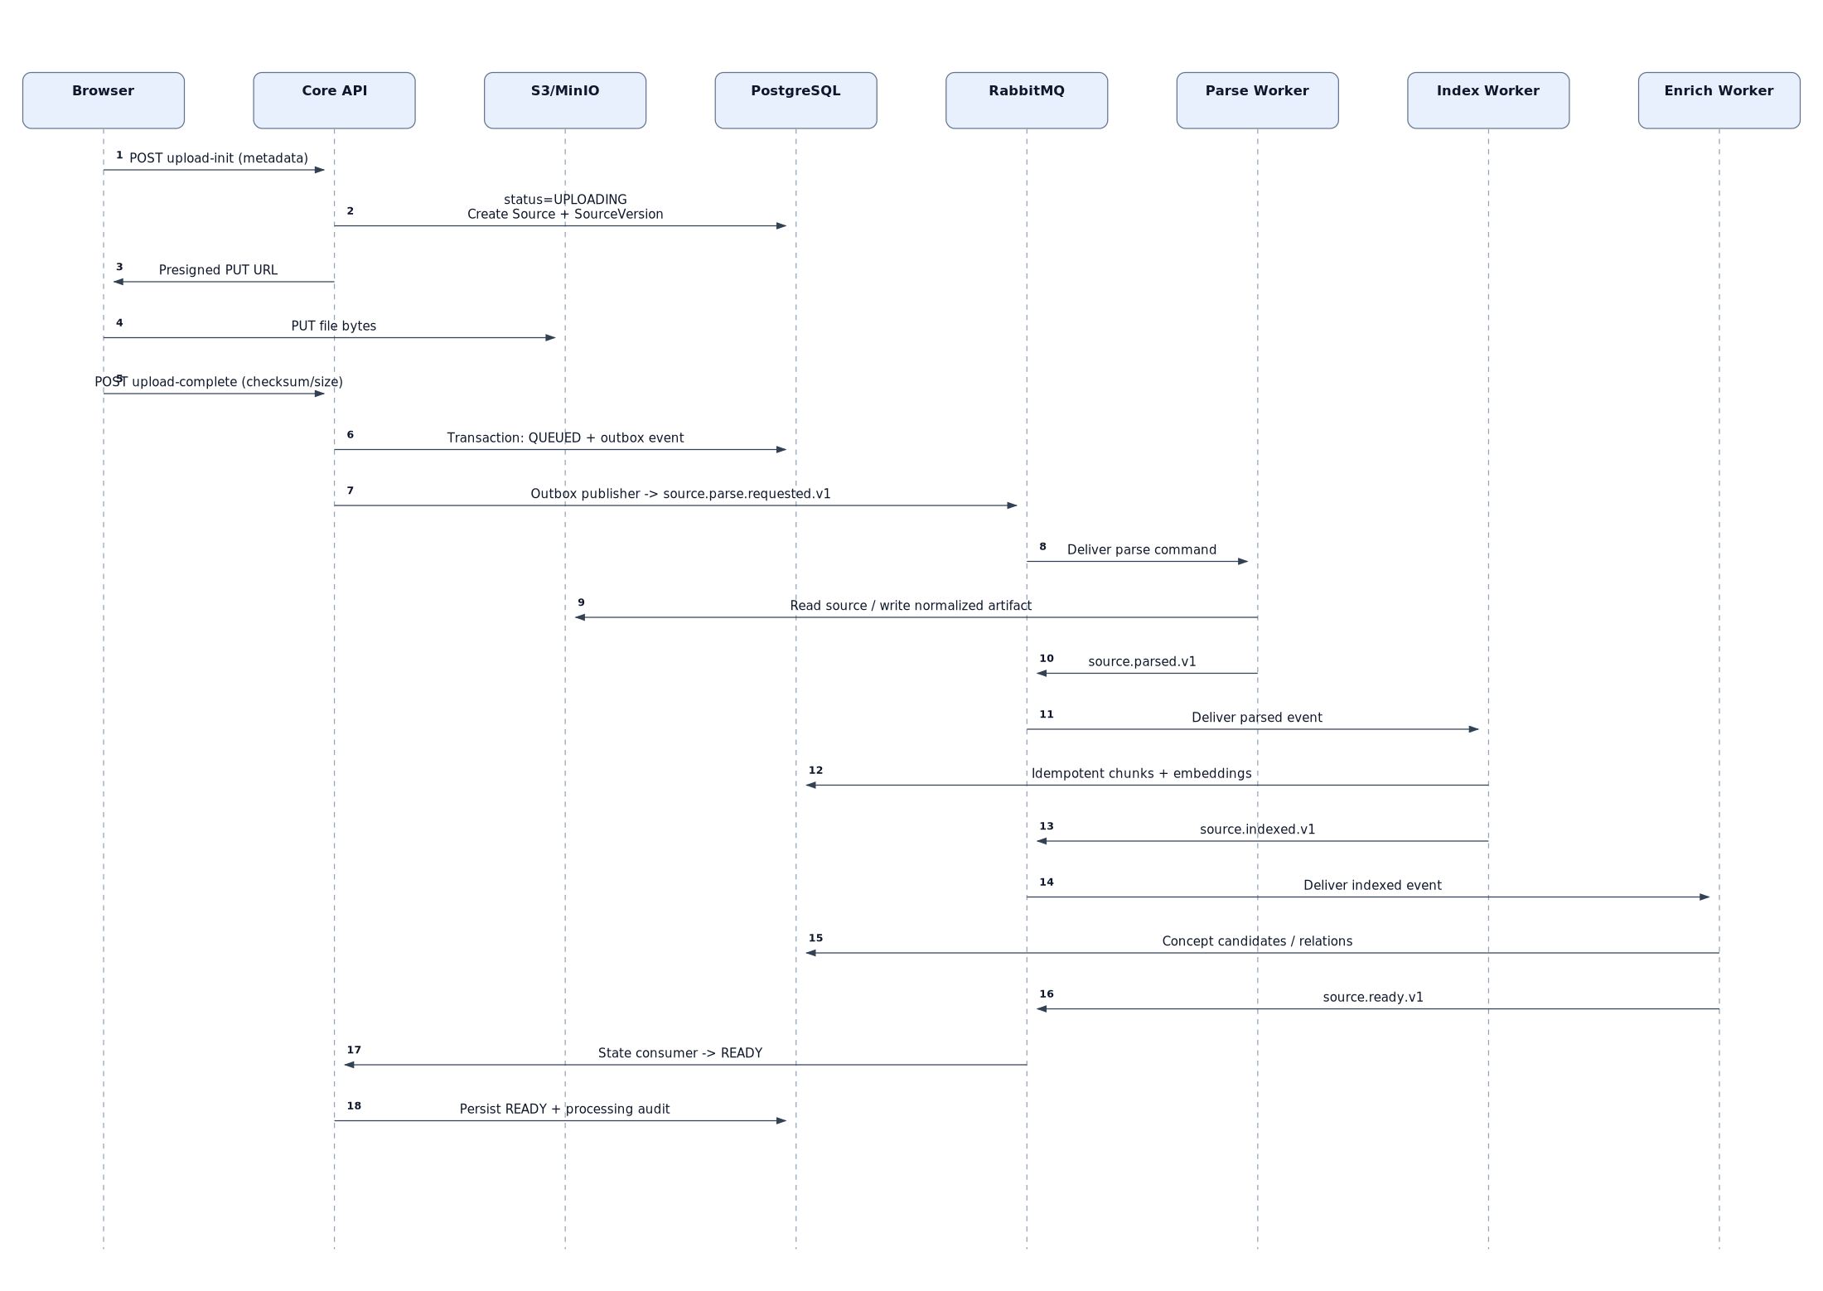

8.1.1 Invariants
- file upload does not synchronously parse/embed;
- Core persists QUEUED + outbox atomically;
- every worker is idempotent;
- source becomes READY only after required stages succeed;
- illegal backward state transitions are ignored/rejected.

8.1.2 Failure paths
- checksum/object mismatch -> fail before parse event;
- parser unsupported/corrupt -> source.processing.failed.v1, retryable=false;
- transient embedding error -> retry queue;
- duplicate parsed/indexed event -> no duplicate chunks because deterministic unique keys.

8.2 2. Flow 2 - Grounded AI Chat over WebSocket
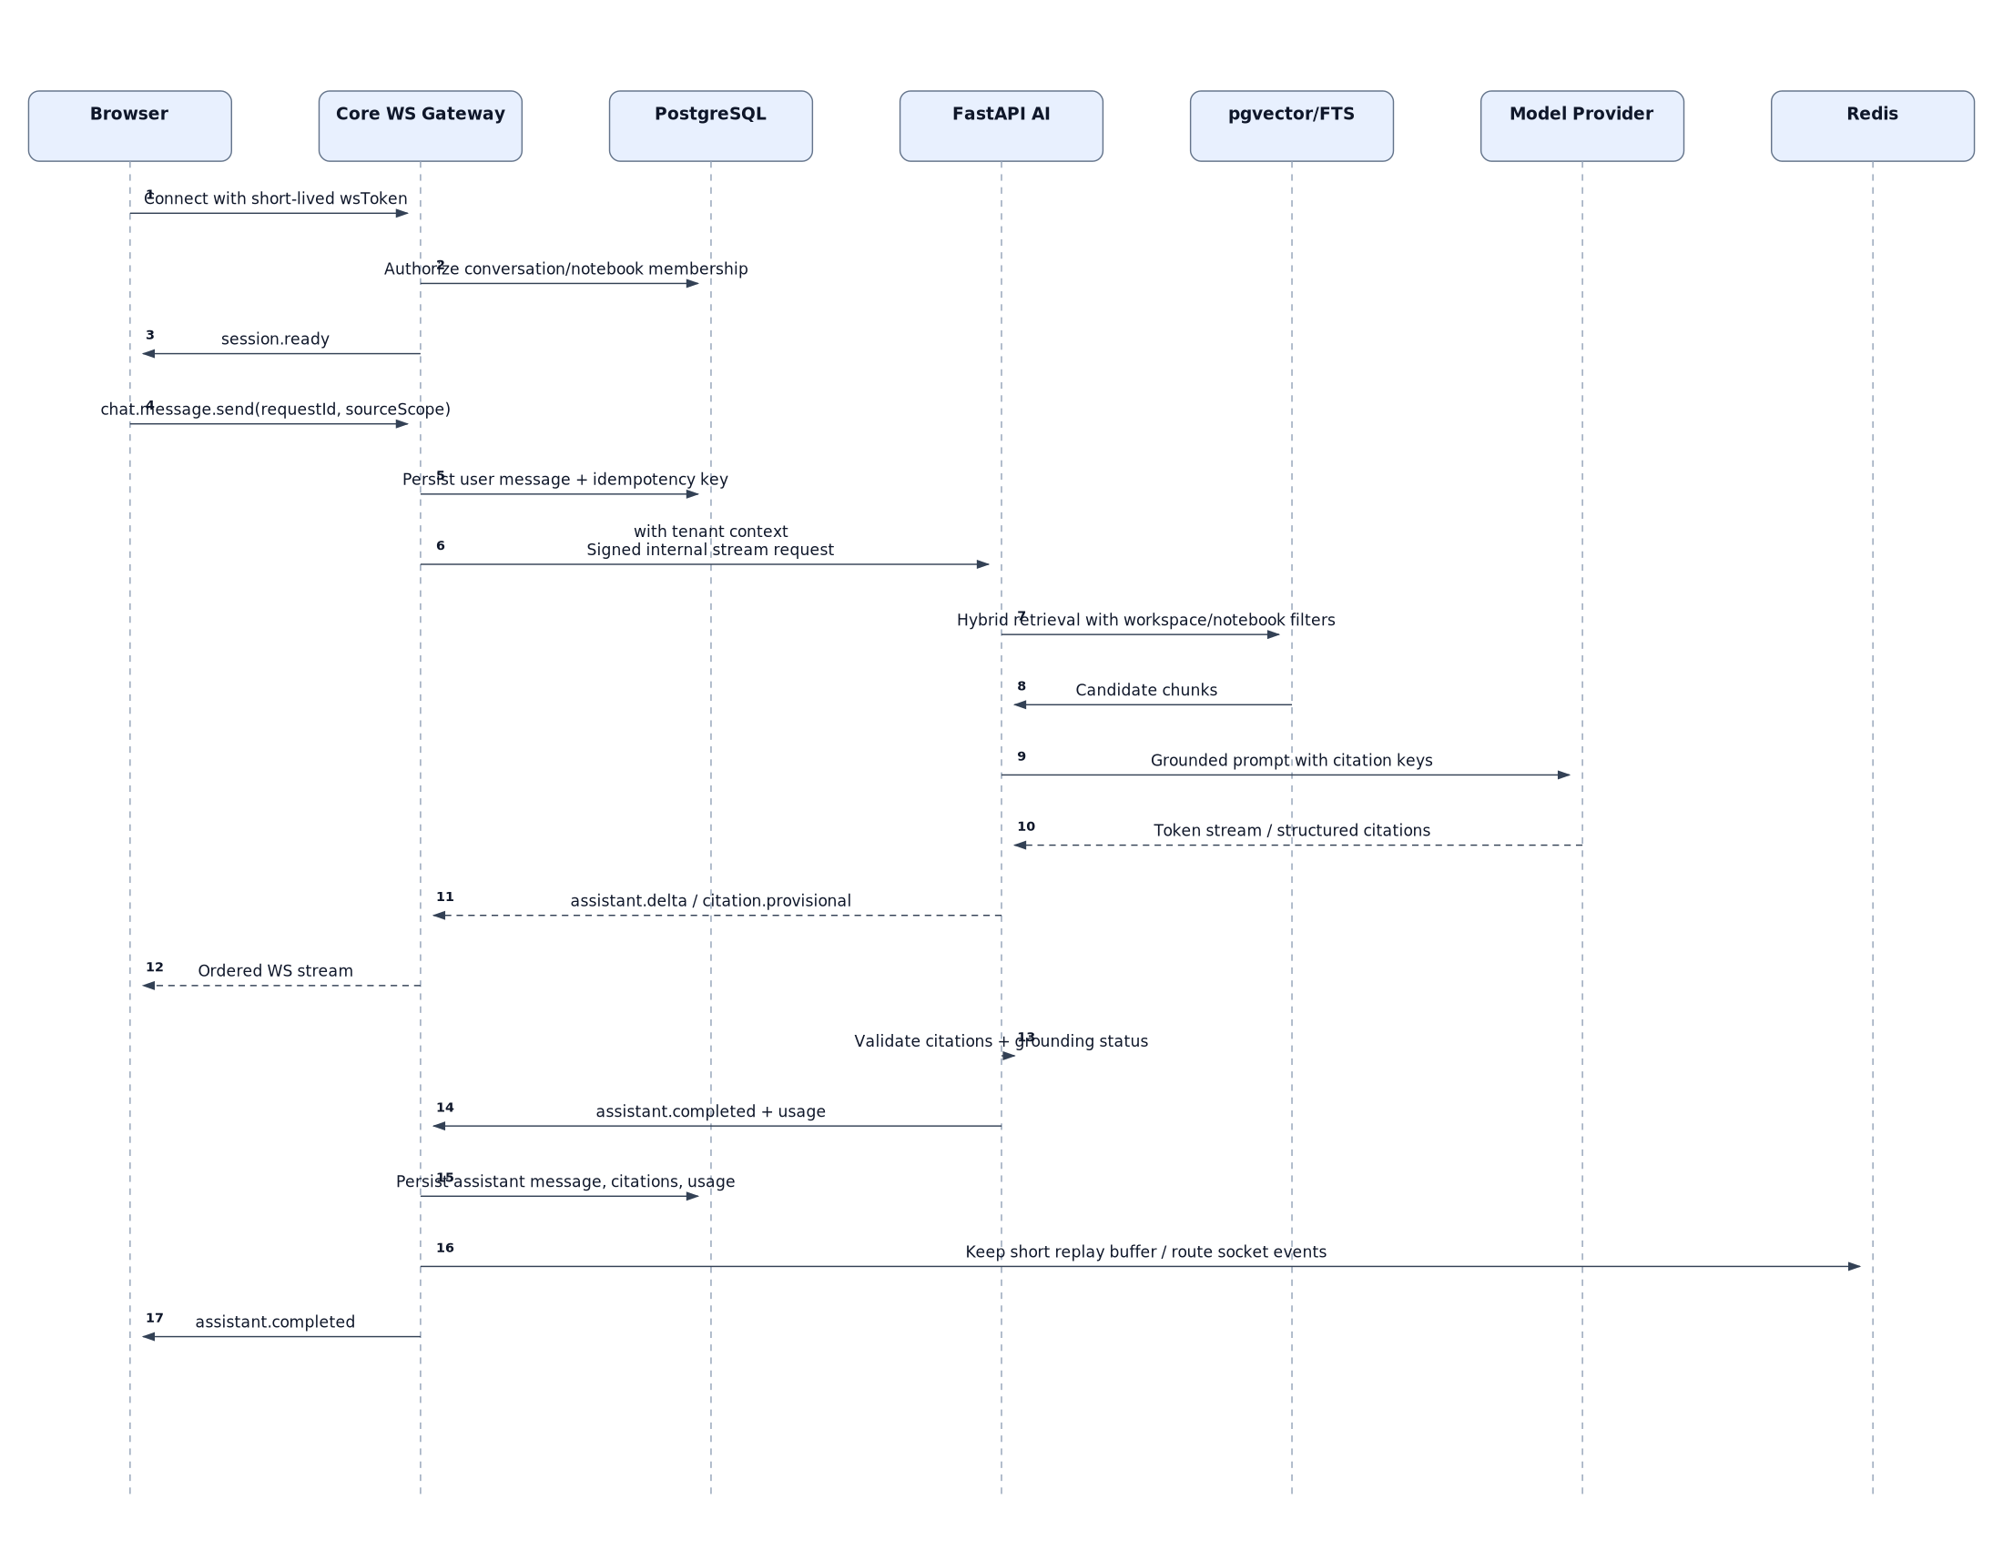

8.2.1 Invariants
- browser socket terminates at Core;
- user message persisted before AI execution;
- FastAPI receives signed tenant context;
- retrieval is workspace/notebook scoped;
- citation IDs are validated against retrieved chunks;
- final assistant message is durable even though partial deltas are transient.

8.2.2 Insufficient evidence behavior
If retrieval/context does not support a grounded answer, AI returns INSUFFICIENT or PARTIAL. The application should say evidence is insufficient rather than fabricate a citation.

8.3 3. Flow 3 - Quiz Generation, Attempt and Mastery Update
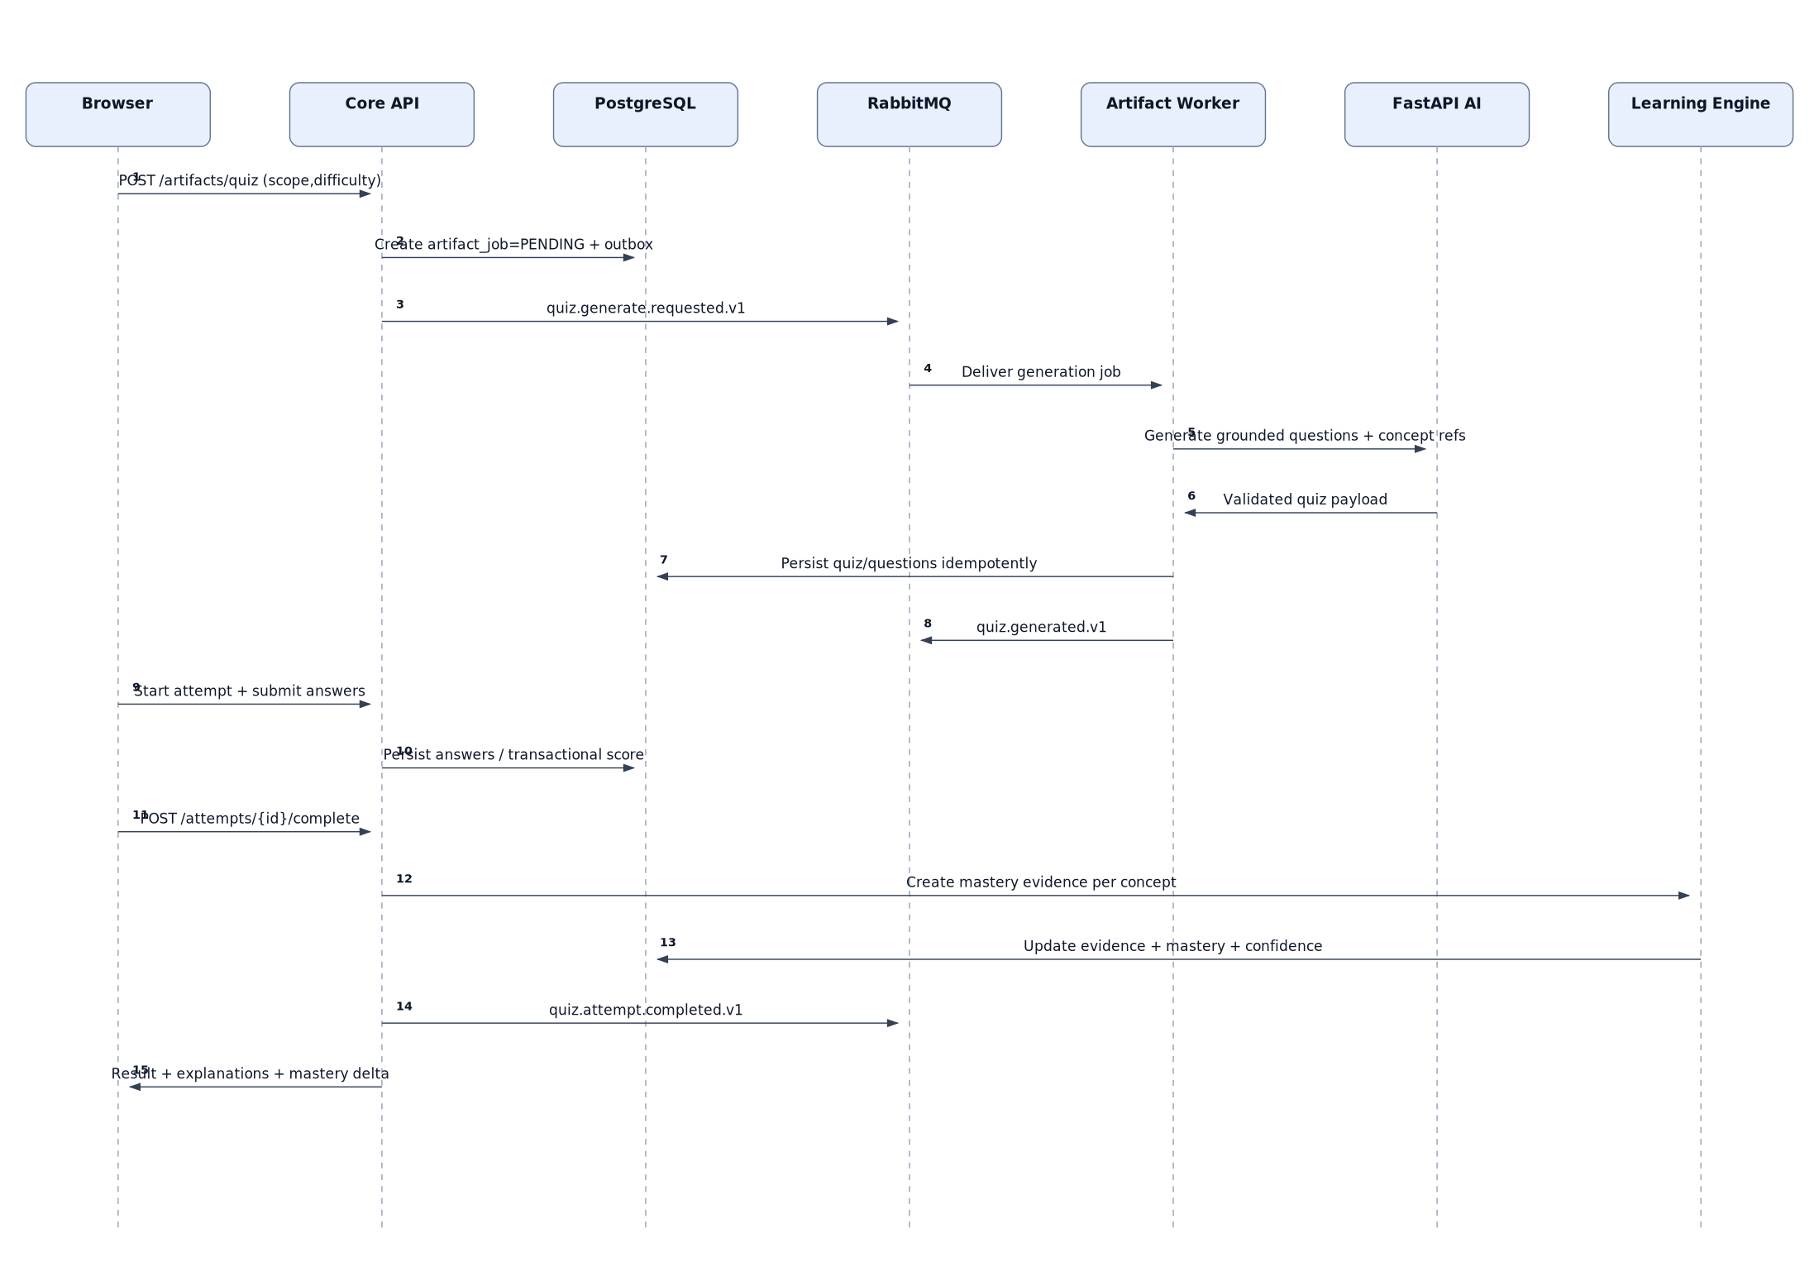

8.3.1 Invariants
- quiz generation may be async, but quiz attempt/scoring is Core-owned;
- generated questions retain source/concept provenance;
- completing an attempt is idempotent;
- mastery changes only from explicit evidence;
- evidence history is append-only for auditability.

8.3.2 Important transaction
Attempt finalization + evidence insertion + mastery projection update are one logical transactional unit. If asynchronous analytics publication fails, outbox preserves the event for later delivery.

8.4 4. Flow 4 - Flashcard Review and Spaced Scheduling
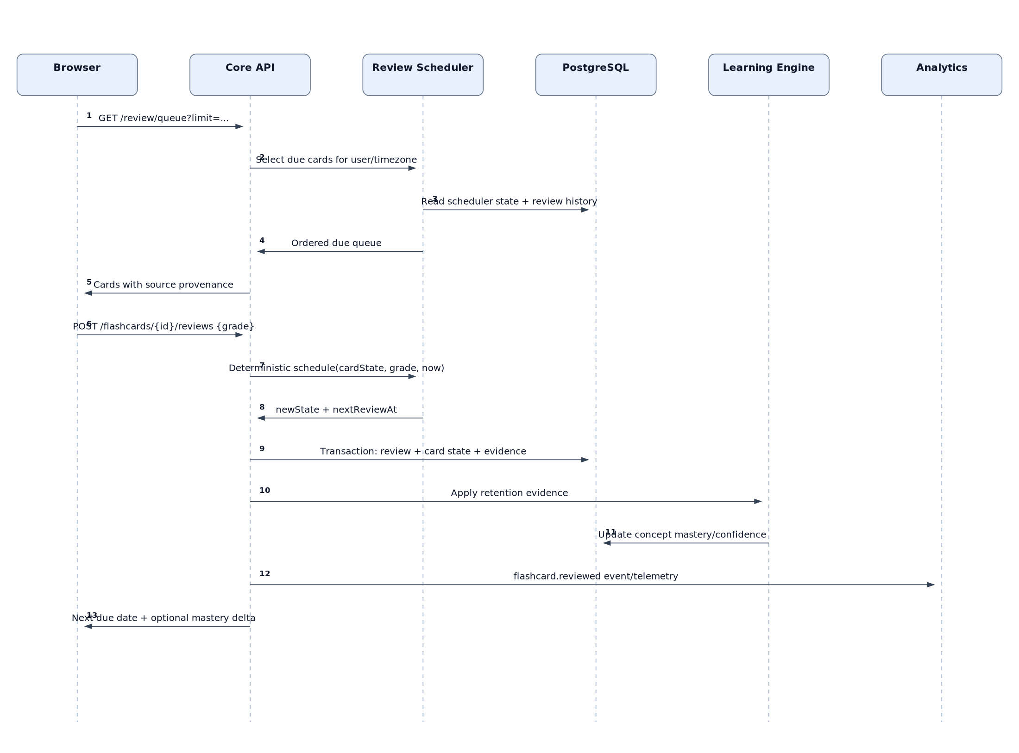

8.4.1 Invariants
- scheduler is deterministic and independent from LLM;
- user review history is private per user;
- the same review request cannot be applied twice;
- scheduler state and immutable review record change in one transaction;
- concept-linked recall creates mastery evidence with conservative weight.

8.4.2 Concurrency
Lock/optimistically version the current card state to avoid two tabs grading the same due card and producing inconsistent schedules.

8.5 5. Flow 5 - YouTube Language Lab to Vocabulary Review
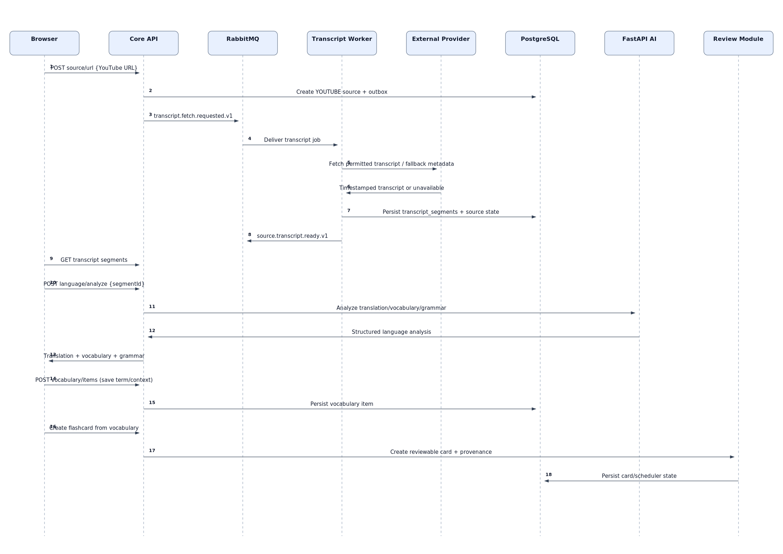

8.5.1 Invariants
- transcript acquisition is provider-abstracted and may legitimately be unavailable;
- timestamped transcript is stored as source-derived data;
- translation/grammar/vocabulary analysis is structured AI output;
- saved vocabulary preserves source sentence/timestamp provenance;
- "create flashcard" enters the same general Review module, not a parallel scheduler.

8.5.2 Failure path
If transcript acquisition is unavailable, the source remains usable only for metadata/manual transcript fallback if product supports it. The system must not falsely claim a transcript was fetched.

8.6 6. Cross-Flow Traceability
Every critical flow carries:
- traceId across HTTP/internal HTTP/RabbitMQ/model calls;
- tenant/workspace scope where applicable;
- requestId/eventId idempotency identifiers;
- user-safe error code;
- audit or operational telemetry for state-changing events.

9 Implementation Backlog Summary
The detailed implementation backlog is delivered separately in 08_Backlog_Epic_UserStory_Task.md, backlog/backlog.csv and backlog/backlog.json. The complete hierarchy contains 12 epics, 46 user stories and 222 tasks.

9.1 Epic Overview
Epic | Priority | Phase | Stories | Goal
E0 Engineering Foundation | P0 | Sprint 0 | 4 | Create a reproducible repo, local runtime, CI and architecture guardrails before feature work.
E1 Identity & Tenant Isolation | P0 | Sprint 1 | 4 | Authenticate users and enforce workspace-scoped authorization as a platform invariant.
E2 Workspace & Notebook | P0 | Sprint 1-2 | 2 | Give learners a durable tenant-scoped place to organize goals and sources.
E3 Source Ingestion Platform | P0 | Sprint 2-4 | 6 | Turn heterogeneous learning sources into durable normalized, searchable data with visible processing state.
E4 Retrieval & Grounded Chat | P0 | Sprint 5-7 | 5 | Answer questions from user sources with validated citations and resilient real-time streaming.
E5 Notes & Studio | P1 | Sprint 8-9 | 2 | Turn evidence into reusable notes and generated learning artifacts.
E6 Quiz & Flashcard Active Learning | P0 | Sprint 9-11 | 4 | Convert passive source consumption into evidence-producing practice and spaced review.
E7 Learning State & Adaptive Recommendations | P0 | Sprint 10-12 | 4 | Maintain explainable concept-level learner state and recommend the next high-value action.
E8 YouTube Language Lab | P1 | Sprint 12-13 | 4 | Turn authentic video transcripts into integrated translation, vocabulary and spaced review.
E9 Adaptive Tutor Modes | P1 | Sprint 14 | 2 | Use learning state and source evidence to teach interactively without letting the model become the source of truth.
E10 Observability, Security & Production | P0 | Sprint 0-16 | 6 | Make the beta deployable, diagnosable and resilient enough for real users.
E11 Product Analytics & Beta Validation | P1 | Sprint 15-16 | 3 | Measure activation, learning loops and reliability with real users instead of optimizing feature count.

9.2 Story Inventory

9.2.1 E0 - Engineering Foundation
Story | Priority | Points | Depends on
US-0001 Bootstrap monorepo | P0 | 3 | -
US-0002 Local infrastructure with Docker Compose | P0 | 5 | US-0001
US-0003 CI quality gate | P0 | 5 | US-0001
US-0004 Database migration baseline | P0 | 3 | US-0002

9.2.2 E1 - Identity & Tenant Isolation
Story | Priority | Points | Depends on
US-0101 Register and login | P0 | 5 | US-0004
US-0102 Refresh token rotation and logout | P0 | 5 | US-0101
US-0103 Workspace membership and RBAC | P0 | 8 | US-0101
US-0104 Google OAuth sign-in | P1 | 5 | US-0101

9.2.3 E2 - Workspace & Notebook
Story | Priority | Points | Depends on
US-0201 Create and manage notebooks | P0 | 5 | US-0103
US-0202 Notebook goal metadata | P1 | 3 | US-0201

9.2.4 E3 - Source Ingestion Platform
Story | Priority | Points | Depends on
US-0301 Presigned PDF upload | P0 | 8 | US-0201
US-0302 Transactional outbox publisher | P0 | 8 | US-0301
US-0303 PDF parse and normalize worker | P0 | 8 | US-0302
US-0304 Chunk and embedding index | P0 | 8 | US-0303
US-0305 Concept enrichment and READY transition | P1 | 8 | US-0304
US-0306 URL and raw text sources | P1 | 5 | US-0302

9.2.5 E4 - Retrieval & Grounded Chat
Story | Priority | Points | Depends on
US-0401 Hybrid retrieval baseline | P0 | 8 | US-0304
US-0402 Grounded answer and citation validation | P0 | 8 | US-0401
US-0403 Conversation persistence | P0 | 5 | US-0201
US-0404 Production WebSocket chat | P0 | 13 | US-0402, US-0403
US-0405 Reranking and RAG evaluation gate | P1 | 8 | US-0401

9.2.6 E5 - Notes & Studio
Story | Priority | Points | Depends on
US-0501 Source-linked notes | P1 | 5 | US-0403
US-0502 Artifact job framework | P1 | 8 | US-0302, US-0402

9.2.7 E6 - Quiz & Flashcard Active Learning
Story | Priority | Points | Depends on
US-0601 Grounded quiz generation | P0 | 8 | US-0502
US-0602 Quiz attempt and scoring | P0 | 8 | US-0601
US-0603 Flashcard generation | P0 | 5 | US-0502
US-0604 Spaced review scheduler | P0 | 8 | US-0603

9.2.8 E7 - Learning State & Adaptive Recommendations
Story | Priority | Points | Depends on
US-0701 Mastery evidence from quiz | P0 | 8 | US-0602, US-0305
US-0702 Retention evidence from flashcard reviews | P0 | 5 | US-0604, US-0701
US-0703 Mastery and concept APIs | P0 | 5 | US-0701
US-0704 Explainable recommendation engine v0 | P1 | 8 | US-0702, US-0202

9.2.9 E8 - YouTube Language Lab
Story | Priority | Points | Depends on
US-0801 YouTube source and transcript pipeline | P1 | 8 | US-0302
US-0802 Transcript learning UI | P1 | 5 | US-0801
US-0803 Sentence translation/vocabulary/grammar analysis | P1 | 8 | US-0802, US-0402
US-0804 Save vocabulary to review | P1 | 5 | US-0803, US-0604

9.2.10 E9 - Adaptive Tutor Modes
Story | Priority | Points | Depends on
US-0901 Socratic tutor mode | P1 | 8 | US-0404, US-0703
US-0902 Feynman evaluation mode | P1 | 8 | US-0901

9.2.11 E10 - Observability, Security & Production
Story | Priority | Points | Depends on
US-1001 Distributed tracing and structured logs | P0 | 8 | US-0001
US-1002 Metrics and dashboards | P0 | 8 | US-1001
US-1003 AI and tenant security test suite | P0 | 8 | US-0402, US-0103
US-1004 Rate limits, quotas and cost accounting | P0 | 8 | US-0101, US-0404
US-1005 Production AWS deployment with Terraform | P0 | 13 | US-0003, US-1001
US-1006 Load and resilience test | P1 | 8 | US-0404, US-1002

9.2.12 E11 - Product Analytics & Beta Validation
Story | Priority | Points | Depends on
US-1101 Product event taxonomy | P1 | 5 | US-0001
US-1102 Learning overview analytics | P1 | 5 | US-0703, US-1101
US-1103 Invite beta cohort and collect feedback | P1 | 5 | US-1005, US-1101

9.3 Critical Implementation Path
E0 -> E1 -> E2 -> E3 -> E4 -> E6 -> E7 -> E10 closes the first production-capable source-to-mastery loop. E5, E8, E9 and E11 deepen product differentiation after this vertical slice is stable.

10 StudyOS Phase 0 - Architecture Decision Records & Traceability

10.1 1. ADR Register
ADR | Decision | Status | Revisit trigger
ADR-001 | Spring Boot Core starts as modular monolith | Accepted | team/scale/availability evidence requires split
ADR-002 | FastAPI is a separate AI process boundary | Accepted | AI workload becomes trivial or another runtime is demonstrably better
ADR-003 | PostgreSQL + pgvector + PostgreSQL FTS is initial retrieval store | Accepted | measured retrieval scale/latency/ops bottleneck
ADR-004 | RabbitMQ + transactional outbox for durable async workflows | Accepted | workload semantics require another log/stream model
ADR-005 | Browser WebSocket terminates at Core API | Accepted | dedicated real-time gateway is justified by scale
ADR-006 | Mastery is evidence-based and rules-first | Accepted | calibrated data supports a stronger statistical model
ADR-007 | External/retrieved content is untrusted AI input | Accepted | never removed; controls may strengthen
ADR-008 | Presigned object storage for uploads | Accepted | product requires server-side transform-on-upload
ADR-009 | Workspace is the primary tenant boundary | Accepted | organization hierarchy becomes required
ADR-010 | Public/internal/event/WS contracts are explicitly versioned | Accepted | never removed; version policy may evolve

10.2 2. ADR-001 - Modular Monolith Before Microservices
Context: One developer/small team needs strong domain boundaries without operating many distributed services.
Decision: Keep transactional business capabilities in one Spring Boot deployable, split internally by module. AI and workers remain separate because their runtime, dependencies and scaling are materially different.
Consequences:
- easier transactions and local debugging;
- fewer deployment/network failure modes;
- architecture discipline must be enforced with package rules/ArchUnit;
- later service extraction requires explicit API/data ownership migration.

10.3 3. ADR-002 - Spring Core + FastAPI AI Boundary
Context: Core business behavior benefits from Java/Spring ecosystem; AI libraries and LLM orchestration evolve primarily in Python.
Decision: Core owns authentication, tenancy and business state. FastAPI owns AI computation/retrieval. Communication is internal authenticated HTTP streaming for chat and task calls for structured AI work.
Consequence: Avoid sharing business authorization logic in Python. Share contracts, not business repositories.

10.4 4. ADR-003 - PostgreSQL/pgvector Before Dedicated Vector DB
Decision: Use PostgreSQL for relational truth, FTS and vector search initially.
Rationale: Simplifies tenant filtering, backup, local development and operational footprint. A separate vector store is introduced only after a benchmark demonstrates a real limitation.

10.5 5. ADR-004 - RabbitMQ + Transactional Outbox
Decision: Use RabbitMQ for long-running asynchronous tasks and outbox for atomic business-change-to-message publication.
Consequences: At-least-once delivery, idempotent consumers, retry/DLQ operations and event versioning are mandatory.

10.6 6. ADR-005 - Core-Owned WebSocket Boundary
Decision: Client WebSocket terminates in Spring Core. FastAPI streams internally to Core.
Rationale: Authentication, quota enforcement, conversation idempotency and persistence stay in one public security boundary.
Trade-off: Core performs stream proxying. If chat scale dominates later, extract a real-time gateway while preserving the protocol.

10.7 7. ADR-006 - Evidence-Based Mastery
Decision: Mastery changes only from evidence-producing learner actions. Score and confidence are separate. Begin with a transparent deterministic model.
Rejected alternative: Ask an LLM to assign mastery from conversation alone. Reason: poor calibration, hard to reproduce/audit and too easy to inflate.

10.8 8. ADR-007 - Retrieved Content Is Untrusted
Decision: PDF/web/transcript text is data, never authority. It cannot change system policy, grant tool permission or access other tenants.
Implementation implications: instruction/data delimiter, tool allowlist, authorization before retrieval, output validation and adversarial tests.

10.9 9. ADR-008 - Presigned Uploads
Decision: Core initializes and authorizes upload; browser uploads directly to object storage; Core verifies completion and queues processing.
Benefits: avoids large file bytes tying up app servers and scales storage bandwidth independently.

10.10 10. ADR-009 - Workspace Tenant Boundary
All primary resources resolve to one workspace. Personal users receive a personal workspace. Future team/education plans reuse the same boundary rather than redesigning authorization.

10.11 11. ADR-010 - Contract Versioning
- REST: /api/v1 and /internal/v1.
- WebSocket: protocolVersion: 1.0.
- Events: name/routing key includes .v1.
- Prompt/retrieval configurations have independent version labels for evaluation.

10.12 12. Critical Requirement Traceability Matrix
Product capability | Core module | Main tables | REST/WS contract | RabbitMQ | Primary stories
Account/session | Identity | users, identities, refresh_tokens | /auth/*, /me | - | US-0101, US-0102
Tenant isolation | Workspace | workspaces, workspace_members | workspace/notebook paths | all events carry workspaceId | US-0103
Notebook | Notebook | notebooks | /workspaces/{id}/notebooks, /notebooks/{id} | - | US-0201
File source | Source | sources, versions, jobs | upload-init/complete/status | source.parse.requested + source events | US-0301..0305
Retrieval | AI service | document_chunks | internal retrieval/chat | source.indexed informs readiness | US-0401
Grounded citation | Conversation + AI | messages, citations, chunks | WebSocket + messages | - | US-0402..0404
Quiz | Studio/Quiz | artifact_jobs, quizzes, attempts | artifact + quiz paths | quiz.generate / quiz.generated / attempt.completed | US-0601, US-0602
Flashcard/review | Review | decks, cards, reviews | review queue / grade | flashcard.reviewed | US-0603, US-0604
Mastery | Learning | mastery_evidence, user_concept_mastery | /mastery | mastery.updated | US-0701..0703
Recommendation | Learning | goals, recommendations | /learning/recommendations | learning facts as triggers | US-0704
Language Lab | Language/Source | transcript_segments, vocabulary_items | transcript/language/vocabulary | transcript events | US-0801..0804
Production ops | Shared/Analytics | ai_runs, audit, outbox, processed_events | admin/ops later | all queues | US-1001..1006

10.13 13. Phase 0 Freeze Checklist
A design item is considered frozen enough to implement when all are true:
- owner/module is known;
- persistent data owner is known;
- public/internal/event contract is defined where relevant;
- transaction and consistency expectation is stated;
- authorization scope is stated;
- idempotency behavior is stated for retryable operations;
- failure path is defined;
- telemetry/trace identifiers are defined;
- backlog story/task exists.
If implementation reveals an invalid assumption, update the ADR and contract first, then code. Phase 0 is a baseline, not a prohibition on learning.

11 Appendix - Machine-Readable Contract Index

11.1 REST Contracts
- contracts/openapi-core.yaml: 46 browser-facing REST paths, 26 shared response/request schemas.
- contracts/openapi-ai-internal.yaml: 5 internal Core-to-AI service paths.

11.2 Messaging Contracts
- contracts/asyncapi-rabbitmq.yaml: 13 asynchronous channels/messages covering source, transcript, artifact and learning facts.
- contracts/event-envelope.schema.json: common durable event envelope.

11.3 WebSocket Contracts
- contracts/websocket-protocol.schema.json: public frame envelope and allowed event types.
- contracts/websocket-examples.json: representative client/server payloads.

11.4 Database
- database/schema.sql: PostgreSQL/pgvector baseline including extensions, enums, tables, constraints and indexes.
- database/studyos.dbml: importable ERD source.

11.5 Backlog
- 08_Backlog_Epic_UserStory_Task.md: human-readable complete hierarchy.
- backlog/backlog.csv: task-level import file.
- backlog/backlog.json: structured hierarchy.

11.6 Diagram Sources
All C4, ERD and sequence diagrams are provided in both PNG and SVG. SVG is the preferred zoomable source for architecture review; PNG is embedded in Word/PDF.

11.7 Contract Change Policy
Any implementation change that alters a public field, event semantic, WebSocket command/event, table invariant or module ownership must update the corresponding artifact in the same pull request.

